

CenturyLink Local Service Ordering System Consolidation Plan

CenturyLink Local Service Ordering
System Consolidation Plan
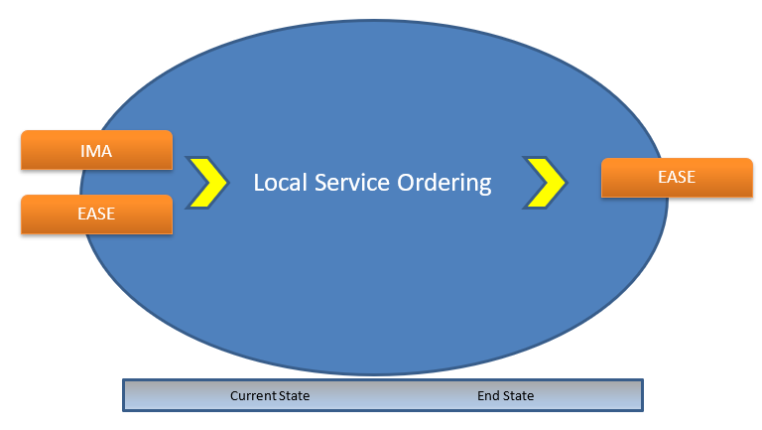

Version 1.1 2/23/20

Document Modification Log

All revisions to this document are in chronological order.

Version | Date | Description of Change
1.1 | 2/23/2020 | Modification of Functionality Matrix

© 2020 CenturyLink, Inc., All Rights Reserved. The CenturyLink mark, pathways logo, and certain CenturyLink product names mentioned herein are the property of CenturyLink, Inc. All other marks are the property of their respective owners.

Contents
CenturyLink Local Service Ordering and Billing System Consolidation Plan 1
1 Executive Summary 5
1.1 Scope 5
1.1.1 Items Not in Scope: 5
1.2 Assumptions 6
2 Ordering and Billing System Description 7
2.1 Current State System View 7
2.1.1 IMA ordering platform 8
2.1.2 EASE ordering platform 8
2.2 End State System View 9
2.2.1 Transition to common processes and system infrastructure 9
2.3 Local Service Ordering End State System - EASE 10
2.3.1 Service Ordering Comparison – IMA to EASE (LSOG 2Q19) 11
2.3.1.1 Pre-Ordering 12
2.3.1.2 Ordering 12
2.3.1.3 Post Order Functionality 13
3 Consolidation Plan Implementation 14
3.1 Consolidation Plan Schedule and Milestones 14
3.1.1 Conversion Approach 14
3.1.2 Schedule and Milestones 14
3.2 Consolidation Plan Implementation 15
3.2.1 Internal CenturyLink Consolidation Testing 15
3.2.2 Training and Process Plan 16
3.2.3 Customer Testing 16
3.2.4 Load & Performance (L&P) Testing 16
3.2.5 Production Conversion Plan 16
3.2.6 Post Conversion Support 17
3.2.7 Contingency Plan 17
Appendix A: Regulatory Organizations, Guidelines and Standards 18
Appendix B: Glossary 19

Executive Summary
CenturyLink is consolidating Local Service ordering to streamline procedure and systems across CenturyLink’s markets (hereafter, Consolidation). Due to Acquisitions (see Section 1.3), CenturyLink currently operates two different ordering systems for purchase of Local Services. As a result, customers who operate in multiple locations within CenturyLink’s network utilize both systems making this inefficient for the customer and for CenturyLink.
During Consolidation, CenturyLink will move all Local Service Request ordering to Electronic Administration & Service Order Exchange (EASE). (Refer to Section: 2: Ordering and Billing System Description for more information.) This Consolidation will migate ordering off the Interconnect Mediated Access (IMA) system and onto the EASE system across all markets and geographies.
The benefits are:
- Single standardized order entry channel for Local Service Request submission
- Standardized process for Local Service Request handling
- Single view of all Local Service Requests
- One set of training requirements

Scope
The CenturyLink Local Service Ordering System Consolidation Plan (hereafter; the Consolidation Plan) document provides CenturyLink’s wholesale customers, (hereafter; Customers) with further information about the Consolidation and how they will be affected.
The purpose of this document is to cover the scope of the Consolidation Plan to fulfill specific requirements of settlement agreements with various parties, as well as associated state commission and FCC orders, related to the CenturyLink/Qwest merger (hereafter, Merger Requirements). This document summarizes the critical milestones that will occur when CenturyLink consolidates the Current State Ordering System into the End State solution. The Consolidation is planned to begin no earlier than October 16, 2020.

Items Not in Scope:
Items that are not in-scope for this project include, but are not limited to:
- Future system enhancements to EASE resulting from Local Service Ordering Guidelines (LSOG) updates beyond the upgrades specified in this project
- Merger of End State Billing Systems.

Assumptions
The following is a list of assumptions that are applicable during implementation and upon completion of the Consolidation:
- CenturyLink will utilize the existing Qwest Corporation d/b/a CenturyLink Change Management Process (CMP) to communicate system and product/process changes in the appropriate timing and format. CenturyLink will fully utilize CMP post Consolidation. To view the complete CMP document, visit the CMP Website or click on the Wholesale Change Management Process Document link
- Customers will enter new Local Service Requests in EASE.
- Customers will populate Local Service Requests in LSOG (Issue 2Q19 Dated May 31, 2019) standard format and in the 2nd version of XML format
- In-Flight Local Service Requests will continue ordering processing thru the IMA system.
In-Flight Local Service Requests are:
When Customers submit Local Service Requests and CenturyLink acknowledges acceptance, but the processing of the Local Service Requests are not complete before the Consolidation weekend.
- IMA will retain inquiry capability of historical information on-line for 24 months from the completion of the IMA request.
- The LSR Consolidation will support the regulatory requirements for PID/PAP reporting. Data sourced in the retiring applications will be replaced with data from the newly introduced applications.

- As the project progresses, analysis and design activities may result in modifications to the Consolidation Plan.

- CenturyLink will comply with all applicable Merger Requirements

Ordering and Billing System Description
This section provides Customers with Current State and End State Ordering system views, common features, and information about the differences between Current State and End State systems. It also provides information about the functionality and applications that CenturyLink uses to facilitate Customer and system interfaces.

Current State System View
Century Link currently requires Customers, based on end user location, the use of two different systems to submit Local Service Requests, EASE and IMA.

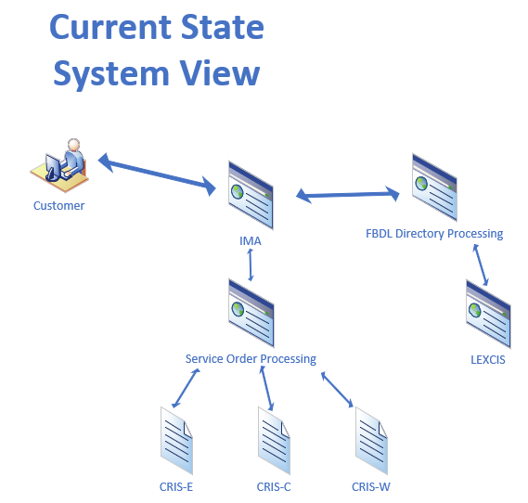

IMA ordering platform

IMA is the current Local Service Request application supporting Local Service Requests for wholesale customers in the Legacy Qwest markets of CenturyLink. IMA includes a GUI application for direct order entry of Local Service Requests, pre-order inquiry and review of statuses and notifications. IMA also provides an electronic bonding gateway using XML to support system-to-system integration.

EASE ordering platform
EASE is the end-state Local Service Request ordering application to be used by Customers, as well as CenturyLink, allowing Local Service Request processing via a GUI, batch files, and real-time XML transactions.
Included within EASE are:
- Edits
- Validations
- Pre-order information queries
- Status information

End State System View

Transition to common processes and system infrastructure

Customers will submit the Local Service Request via the EASE system. EASE will determine the area

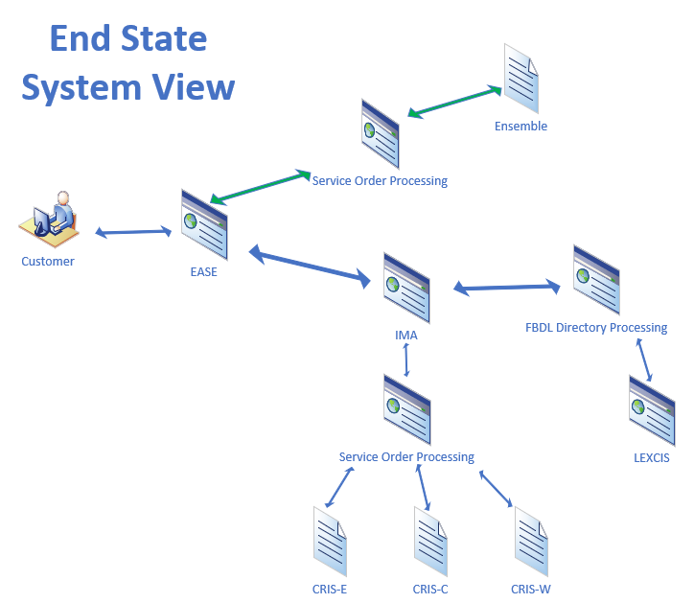

Local Service Ordering End State System - EASE
EASE is an industry-compliant order entry and workforce management system that allows end-to-end review and management of Local Service Requests. The system consists of GUI and UOM/XML ordering capabilities. The system is robust and table driven with extensive business rule capabilities.
EASE follows industry-standard ordering business rules, including LSOG-based updates. EASE provides the following:
- Single, centralized platform for all Local Service Request processing
  - Supports both eBonding and Portal (Virtual Front Office (VFO) GUI) capabilities.
- Compliance with LSOG/Local Service Request industry standards and standard Local Service Request configurations
  - Manages all LSOG updates going forward.
- Integration with back office systems
  - Platform Application Programming Interface (API) to support additional integrations as needed for all Local Service Request volumes.
  - EASE will provide the front end interface for customers and ultilize the existing downstream IMA platforms for Pre-order / Order processing after receipt.
- Platform Expandability
  - Local Number Portability (LNP) / Local Service Request (Local Service Request) / Receive custom transaction types.

Service Ordering Comparison – IMA to EASE (LSOG 2Q19)

The following matrices provide a comparison of current IMA functionality and EASE Local Service Request functionality that will be available in user acceptance testing and deployed prior to conversion including planned development.
General Functionality | IMA | EASE
Support eBonding and portal for Local Service Request requests | Yes | Yes
LSOG Ver 2Q19 Compliant | No | Yes
Auto-populate initiator information from User Profile | Yes | Yes
Field Level Help | Yes | Yes
Error messaging – identifies form and fields | Yes | Yes
Auto navigation to fields in error | No | Yes
Recapping from pre-order to Local Service Request | Yes | Yes
Multiple versions of XML | Yes | Yes
Manage Users | Yes | Yes
Agent owner relationships | Yes | Yes

*Indicates some development may be required prior to testing

Pre-Ordering
Pre-Order Functionality | IMA | EASE
Address Validation (by Street Address or TN) | Yes | Yes
Appointment Scheduler Query (Select, Change, or Cancel) | Yes | Yes
Carrier Facility Assignment Validation (Cable Facility, CFA Groups or Units queries) | Yes | Yes
Customer Service Inquiry & Virtual Customer Service Inquiry Retrieval (by Street Address or TN) | Yes | Yes
Directory Listing Inquiry (by Account TN, Listed TN, Non-Standard TN, Caption Name, or SLU Header TN) | Yes | Yes
Design Layout Record Query (by Serial Number Circuit, TN Circuit, Carriers Facility Circuit, or Message Trunk Circuit) | Yes | Yes
Facility Availability Validation (by TN, Address, or Circuit) | Yes | Yes
Loop Qualification Query (by TN or Circuit) | Yes | Yes
Meet Point Query (POTS Splitter or Cable Connection queries) | Yes | Yes
Raw Loop Data Query (by TN, Address, or Circuit) | Yes | Yes
Service Availability Query (by State and Service Type) | Yes | Yes
TN Reservation Query (by Address and Custom TN selection criteria) | Yes | Yes

*Indicates development completed to provide similar funcationality

Ordering

Order Functionality | IMA | EASE
Create and submit a request | Yes | Yes*
Revise and resubmit a rejected request | Yes | Yes
Supplement a request | Yes | Yes
Up front order editing | Yes | Yes
Search Local Service Requests | Yes | Yes
Wildcard search | Yes | Yes
Local Service Request replication and template creation | Yes | Yes

Post Order Functionality | IMA | EASE
Viewing and retrieving line loss information (by Account Number, Working TN, Circuit, Order number, PON, or Completion Date) | Yes | Yes
Status by Local Service Request and/or Service Orders
Error | Yes | Yes
Issued FOC | Yes | Yes
Jeopardy (Local Service Request) | Yes | Yes
Jeopardy (Internal Service Order) | Yes | Yes
Order Completed | Yes | Yes
Physical Work Completed | Yes | Yes
Posted to be billed | Yes | Yes
Rejected | Yes | Yes
Request Completed | Yes | Yes
Notification Inquiries
BCN | Yes | Yes
Bulk | Yes | Yes
Completion | Yes | Yes
Confirmation | Yes | Yes
Error | Yes | Yes
Jeopardy | Yes | Yes
PSON | Yes | Yes
Reject | Yes | Yes
CFA Inventory | Yes | Yes*

Post Order Functionality
*Indicates development completed to provide similar funcationality

Note: Technical, legal and regulatory changes may affect information provided in the above table. Changes made following the introduction of this document in CMP are not reflected in the table above. This section is not intended to provide a complete listing of all capabilities.

Follow the link to access LSOG: http://www.atis.org/obf/download.asp

Consolidation Plan Implementation

Consolidation Plan Schedule and Milestones

Conversion Approach

All customers will be required to submit all LSR requests into the EASE LSR Platform on October 16, 2020. If desired, customers may work with CenturyLink prior to conversion to begin utilizing the platform as early as May of 2020.

Schedule and Milestones

Consolidation completion is targeted for September 2020. CenturyLink will follow the CMP process where it applies. This document will be updated when target dates are available for later phases.
The following table shows milestones that reflect the Consolidation Plan trajectory. CenturyLink will communicate updated milestones per the CMP process.
= A milestone, established by the Merger Requirements, that alters the established CMP milestones schedule.
Consolidation Plan Milestone | Date
CMP CR Issuance: SCRxxxxx  These can be found at: http://www.centurylink.com/wholesale/cmp/cr/crnumber_system_index.html | 12/2/19
CR Presentation at CMP Meeting | 12/18/19
Local Service Request Consolidation Plan due | 1/13/2020
Local Service Request Consolidation Plan Review Meeting | 1/22/2020
Extended Customer Comment Window for Initial Release Notification, Initial Retirement Notice and Consolidation Plan | 2/5/2020
CenturyLink issues response to CLEC comments including the Final version of the Local Service Request Consolidation Plan | 2/26/2020
Draft Interface Tech Specs | 3/18/2020
Tech Specs Walk-through | 3/25/2020 – 4/15/2020
CLEC Comments for Interface Tech Specs | 4/30/2020
Final Interface Tech Specs | 5/15/2020
Product Process Notification associated with Level 2 OSS changes | 5/15/2020
CLEC comments due on (New) GUI Release Notes | 6/5/2020
CLEC comments due on Level 2 OSS Product Process changes | 6/5/2020
Training available | 6/5/2020
GUI Final Release Notice | 6/19/2020
Final Notice For Level 2 OSS Product/Process Changes | 6/19/2020
Customer Testing Begins with Local Service Request Consolidation Functionality (120 Days) | 6/5/2020
Customer Testing Ends | 10/3/2020
Customer Go/No Go Vote | 10/3/2020

Consolidation Plan Implementation
This section provides further details on the Consolidation Plan implementation, including testing, training, the conversion weekend consolidation plan, and contingency planning.

Internal CenturyLink Consolidation Testing
CenturyLink will execute test Local Service Requests through EASE to ensure that proper billing codes assignation occurs and the Local Service Requests flow successfully into billing. CenturyLink business SMEs (Subject Matter Experts) will check for accuracy and completeness.
The following is the standard process for this system consolidation:
- First, internal testing, fulfilling ‘mock’ orders from inputprocessing through billing, will occur prior to the Customer testing period.
CenturyLink subject matter experts familiar with the EASE/IMA systems and processes will participate in testing and validation.

Training and Process Plan
Per the Merger Agreement, CenturyLink will provide Customer training and education without charge.
During the migration, CenturyLink will provide:
- A Customer walk-through prior to the onset of Customer testing
- An additional Customer walk-through of the training before Consolidation
- Updated external documentation prior to Customer testing

Customer Testing
In accordance with the Merger Agreement, CenturyLink will make available a testing environment at the appropriate time for the Customers to test submission of Local Service Requests via the EASE ordering system. Before testing begins, the process to log and track defects will be communicated.

Load & Performance (L&P) Testing
CenturyLink completed an analysis of the increased demand on EASE to process IMA transactions. CenturyLink modified processing capacity by using internal virtual server environments allowing CenturyLink to respond quickly to capacity issues.
In addition to the completed performance analysis, CenturyLink will perform a Load & Performance test on EASE based on the anticipated volume after the IMA volume is included. Specifically:
- The Load & Performance test will be conducted prior to Consolidation.
- The combined Local Service Request transaction volume for the preceding 36 months will be made available to Customers
- The highest monthly volume of aggregate transactions for the preceding 12 months will serve as the testing baseline
- Using the highest monthly volume, a single day’s average transaction volume of Local Service Requests will be calculated
- 125% of the single day’s transaction volume will be processed and performance metrics captured
- These metrics will be available to Customers

Production Conversion Plan
The Consolidation will begin October 2020. The EASE Local Service Request and will be in use post-conversion. This means that Customers will submit Local Service Requests via IMA pre-Consolidation weekend and new Local Service Requests post-Consolidation will go into EASE. The weekend Consolidation cutover will be for all properties in the impacted regions.
Customers will receive notifications of the Consolidation’s extended weekend maintenance window. There will be a live bridge open at CenturyLink with key CenturyLink resources to immediately investigate and address concerns once production systems are back online. Customers will receive issue ticket logging and escalations processes prior to the Consolidation weekend.

Post Conversion Support
Post-conversion support staff will be available to assist key operational functions. Customers will be supported by their normal operations centers. CenturyLink will ensure its staffing and training will accommodate post conversion demand.

Contingency Plan
In the event of catastrophic issues with the production system during migration weekend, customers would continue to utilize the IMA ordering platform. The implementation of this plan would only occur in the event of catastrophic issues with the production system during that weekend.
Once the consolidation is complete, source databases will be modified to ‘read only’ where applicable.

- Regulatory Organizations, Guidelines and Standards
The following is a list of regulatory organizations, guidelines and industry standards mentioned in this document.
- LSOG (Local Service Ordering Guidelines)
  - http://www.atis.org/obf/download.asp
- CMP (CenturyLink Change Management Process)
  - http://www.centurylink.com/wholesale/cmp/review.html
- FCC (Federal Communications Commission)
  - www.fcc.gov/
- PUC (Public Utility Commissions)
  - The following link is to the National Association of Regulatory Utility Commissioners. You will be able to obtain information about Public Utilities Commissions by State
http://www.naruc.org/Commissions/

- Glossary
The glossary lists terms and acronyms used in this document with descriptions and definitions.
Term/Acronym | Description/Definition
API | Application Programming Interface
BAN | Billing Account Number
CFA | Carrier Facility Assignment
CLEC | Competitive Local Exchange Carrier
CMP | Change Management Process
CRB | Customer Records and Billing
CRIS | Customer Records and Information System
CSR | Customer Service Records
Current State System View | Denotes CenturyLink’s existing systems and their functionality pre-Consolidation
EASE | Electronic Administration & Service Order Exchange
End State System View | Denotes CenturyLink’s systems and functionality post Consolidation
FBDL | Facility Based Directory Listing
FCC | Federal Communications Commission (USA)
GUI | Graphical User Interface
ILEC | Incumbent Local Exchange Carrier
IMA | Interconnect Mediated Access
LEC | Local Exchange Carrier
LEXCIS | Local Exchange Carrier Invoice System
LNP | Local Number Portability
LSOG | Local Service Ordering Guidelines
LSR | Local Service Request
NC | Network Channel
NCI | Network Channel Interface
OSS | Operating Service System
PUC | Public Utility Commissions
RLEC | Rural Local Exchange Carrier
S.O. | Service Order
SOE | Service Order Entry
UOM | Uniform Ordering Model
USOC | Universal Service Order Code
VFO | Virtual Front Office
WTN | Working Telephone Number

