EASE VFO
Administrator’s Guide

Table of Contents
Version Notice 3
Change Log 3
Document Location 3
Records Retention Policy 3
Introduction 4
Browser Guidelines 4
Navigating EASE 4
Admin Tab 6
Administrative Roles and Tasks 6
Password Rules 6
Creating a New User 7
Search for Users 9
Modify Users 10
Create Display Groups 11
Search and Modify Display Groups 12
Bulk Reassign Display Groups 13
Reassign an Order to a Different User 14
EASE Help 15

Document Information

Version Notice
Document Date | Software Release | Document Version
February 2016 | XX | .01
March 7, 2016 |  | 1.0

Change Log
Revision Date | Document Version & Software Release | Description
February 2016 | .01 | New Document
March 7, 2016 | 1.0 | Final

Document Location
You can obtain the latest version of this document at http://www.centurylink.com/wholesale/systems/ossconsolid.html

Records Retention Policy
ASRs that have been submitted to CenturyLink and processed will be retained in the database for a period of 2 years. CenturyLink will perform a purge of these records twice annually in January and July. The purge date will be based on the date of the last activity transmitted on the ASR. For example, if the date the C/NR form for completion or cancellation of the ASR is November 2015, the deletion of this record would occur in January 2018 and once purged will no longer be accessible to you.

Requests that have been created but not submitted to CenturyLink will not be purged from the database regardless of the date created. However, unsubmitted ASRs that have not been modified for more than 2 years whose "Last Edited User" is no longer a valid user in the system may be purged at CenturyLink's discretion.

Introduction

This Administration guide allows users with Administration rights to search, create and modify Users.

Browser Guidelines
Your browser may ask you whether you want passwords and information you type to be saved for future use. If you see a message asking you to save your password or other information, do not do so. Saving your password may create security problems. Saving other information may not work as intended within the system.

Navigating EASE
To navigate in EASE, use the top row of button and the system tabs:

To Do This….. | Click this button / tab….
Return to the Order List page | Home
Open a pop-up window that lists login name of current user, current user’s full name, date and time the current version of the application was installed, VFO copyright information | About
Access VFO Online Help | Help
Logout of VFO and return to the login page | Logout
Access functionality to create or search for an order | Order
Initiate, search, and / or submit pre-order transactions | PreOrder
Access functionality to create or search for a template | Template
Access User Profiles and other security related information. This tab will only be visible if you have sufficient permissions | Administration

EASE VFO Standards

Following are standard guidelines to follow when working in EASE.

- UPPERCASE must be used when creating orders. Failure to use UPPERCASE may cause issues with your order not routing properly, or not routing at all.

- You can edit all fields unless they are dimmed. Fields that are automatically filled in cannot be edited.

- Avoid copying/pasting text from other applications (Word, Excel, PDF, and so on) into fields. Doing so may introduce "garbage characters" (carriage returns, tabs, line feeds, unsupported non-ASCII characters, and so on) that cannot be interpreted or translated properly when the data is transferred. Once a situation like this occurs, the only workaround is to perform a copy-to-new function and fix the offending field prior to requesting a validation, which forces you to submit the ASR under a different PON. The workaround is cumbersome, and data could be unrecoverable if the situation occurs on a SUP.

EASE VFO System Requirements

Browser: VFO will support Internet Explorer version 10 and Google Chrome, and will be backward compatible with IE8 and IE9. Earlier versions of Internet Explorer will cease to be supported.

Whom to Call and When

If you need an account created or changes to your CCNA permissions or personal information (name, email address, etc.), contact your EASE system administrator at Helpdesk.EASE@CenturyLink.com.
For ASR Ordering Systems Information, go to http://ease.centurylink.com/.

Requirement updates and additional questions and answers can be found at the CenturyLink ASR Ordering Systems web site at http://ease.centurylink.com/.

For all other problems, call the Wholesale Systems Help Desk:
1-888-796-9102, option 2

Monday-Friday 6:00 a.m. to 7:00 p.m. (Mountain Time) Saturday 7:00 a.m. to 2:00 p.m. (Mountain Time)

Admin Tab

Administrative Roles and Tasks

EASE supports the roles and administrative tasks outlined in the table below. Your role determines the tasks you can complete from the Admin tab.

Tasks |  | Customer Basic |  | Customer Admin
Create User Profiles |  |  |  | X
Search for Users |  |  |  | X
Modify Users |  |  |  | X
Create Display Groups |  |  |  | X

Password Rules

Customer users can change their own passwords, using the following rules:

Passwords chosen must:

- Be at least 8 characters in length but not more than 16 characters
- Contain at least one character from any three of the following four categories
  - Uppercase alphabets (A-Z)
  - Lowercase alphabets (a-z)
  - Numbers (0-9)
  - Special characters (~ ` ! @ # $ % ^ & * ( ) - _ = + { } [ ] \ | ; : ‘ “ , . < > / ?)

Passwords chosen must not:
- Contain a space
- Be “password” itself
- Be the same as the login user name
- Be the same as the old password that is being changed

Creating a New User

This section provides the steps you use to create new user profiles. As a customer EASE administrator, you can create accounts for other administrators and for basic users within your company. Before you attempt to create a new user profile, make sure you have the necessary user information. The items marked with an “*” are mandatory. The assignment of User Names in the VFO System is global. Duplicate User Names are not permitted. Please ensure that the User Names that are assigned to your User Group(s) are unique.

  - User Name *
  - Password *
  - Full Name
  - Designation
  - User Type *
  - ESP Name
  - Phone
  - Email ID
  - Primary User Group *

After navigating to the Administration Tab and selecting the Security Tab, use the following steps to create a new user:

- Click the User Profile link. This opens the User Profile Search List window.

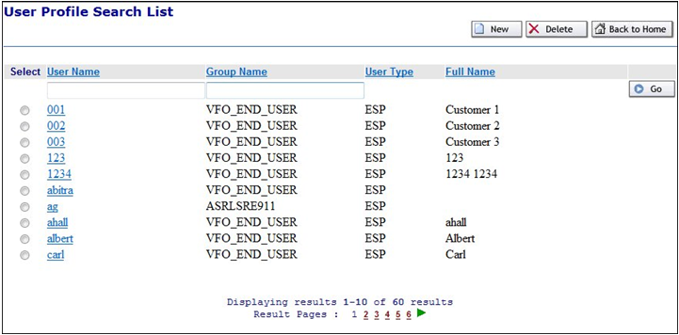

Click New. This opens the User Profile Details page.

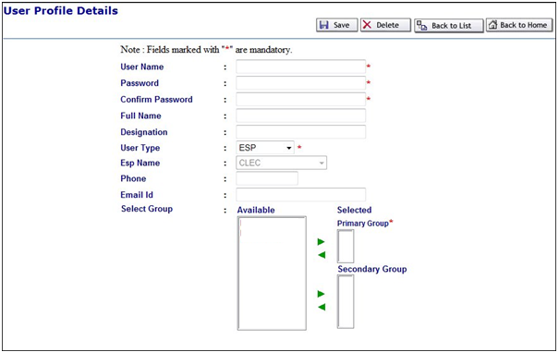

- Enter a unique User Name and Password. Passwords are case sensitive and can be any combination of characters between 8 – 16 characters.
- Re-enter the password into the Confirm Password field.
- Enter a full Name and Designation for the user.
- Select a User Type from the drop down menu. The ESP name is pre-populated based on your user profile.
  - NOTE: The value(s) available in t he User Type drop-down menu is determined by your User Profile configuration. You cannot assign a User Type other than the one you have been assigned.
- Enter a Phone Number and Email ID.
- Select from the available list the Group to which the new user will belong.
- Click the right-pointing arrow that corresponds to the Primary Group field.
- If you wish your new user to belong to a Secondary Group, select another group and click the right-pointing arrow that corresponds to the Secondary Group field to add the privileges associated with that group. This gives the user the privileges of both groups.
- Click Save. This will return you to the User Profile Search window.

Search for Users

After navigating to the Administration Tab and selecting the Security Tab, click the User Profile link to search for a user.

- Enter the User Name you are searching for. You can also search by Group Name the user belongs to.
- You can use the % wildcard search if you don’t know the user name.
  - Example: a% would return all the users with “a” at the beginning of their user name.

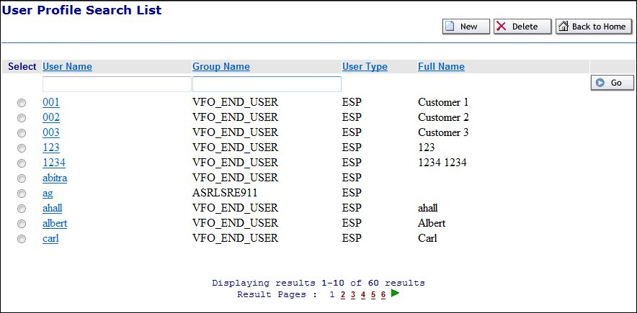

Modify Users

After navigating to the Administration Tab, selecting the Security Tab, selecting the Profile Search List, use the following steps to modify a user.

- On the User Profile Details Page, click the link of the user name you wish to modify. This opens the User profile details window for the selected user.

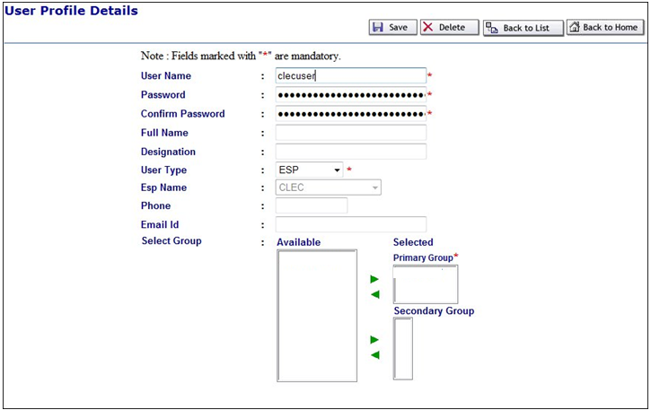

- Make the desired changes.
- Click Save. A status message will appear stating that the profile was successfully updated.

Create Display Groups

Display groups are a set of users grouped for the purpose of filtering the Order List. To create a Display Group:

- Hover over the Administration tab.
- Click the Security menu option
- Select Display Group
- Click New

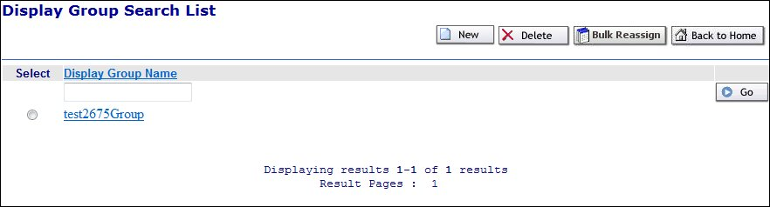

- Enter a Display Group Name, Description, and select users.
- Click Save.

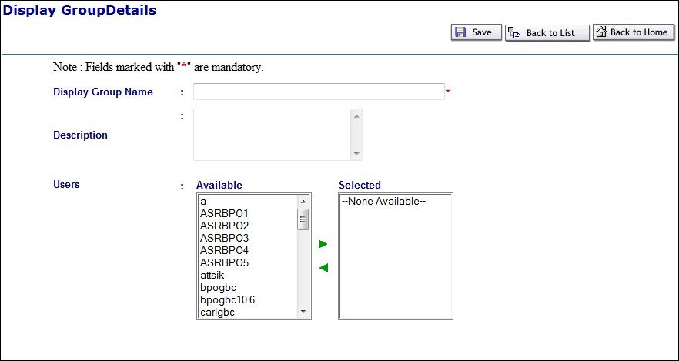

Search and Modify Display Groups

After you have several Display Groups created, you may need to access one to add or remove users from the group. You can search by the Display Group name or use % as a wild card character.

- Hover over the Administration tab.
- Click the Security menu option
- Select Display Group
- Enter Display Group name or part of the name and use % as the wild card character.
- Click the Go button
- Click the Display Group Name to open the group to modify the users associated.

Bulk Reassign Display Groups

To move the users around from one group to another you can use Bulk Reassignment.

- Hover over the Administration tab.
- Click the Security menu option
- Select Display Groups
- Click Bulk Reassignment.

- Select a group from the “From Group” and “To Group” options

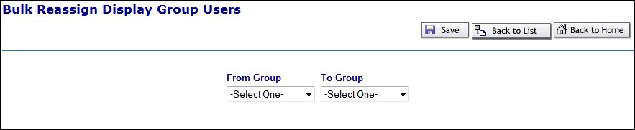
- Click Save

Reassign an Order to a Different User

To reassign an order to a user:

- Select the radio button in front of the order you wish to reassign

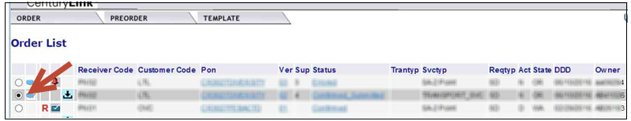

- From the Order Tab
- Select Reassign

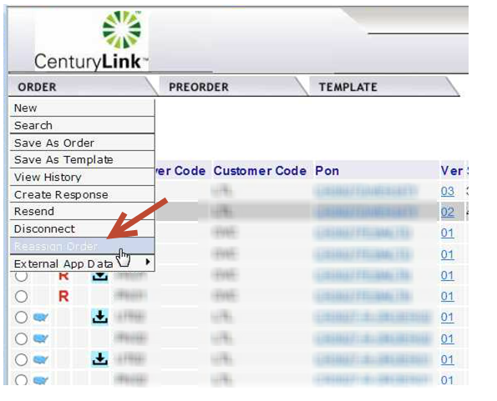

- Select the new user from the drop down menu

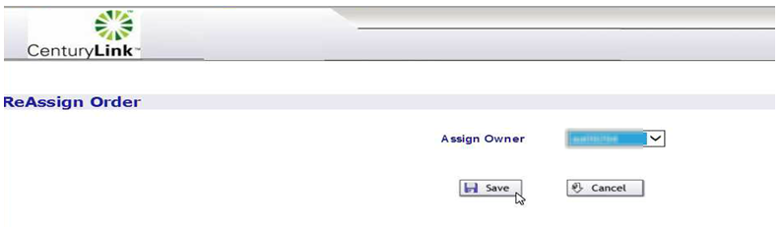

- Select Save

EASE Help

Help text is available for each field once in an order in EASE VFO. The help text may assist the user with correcting errors or choosing valid field values. The help text for each field displays at the bottom of the screen after clicking into the field.

  - Additional Resources

- The ASR Order page URL: http://www.centurylink.com/wholesale/systems/ossconsolid.html

- EASE Training: http://training.centurylink.com/ease

- Address Validation Utility, Virtual Front Office, and Reference Table Maintenance: http://ease.centurylink.com/

- The ASOG document is available from the OBF Document Catalog at ATIS.org.

  - Contact Information

For additional assistance with ASR Inquiries:
- Via Phone: (913)353-7439

- Via Email: Helpdesk.ease@CenturyLink.com

