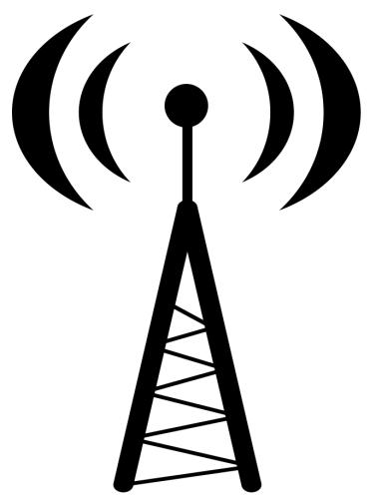
 PCS/Wireless
Cell Site Deployment
Customer Guide

October 2015

www.centurylink.com/wholesale or
http://www.centurylink.com/wholesale/industrysolution/wireless.html

Table of Contents

Section Pages

Table of Contents 2

Introduction 3

Cell Site Specifications, Requirements and Definitions 4-6

CenturyLink Cell Site Build Process 7-12

CenturyLink TOAST Cell Site Build Process 13-16

CenturyLink High Voltage Cell Site Build Process 17-32

CenturyLink Pre-Build Cell Site Process 33-36

Forms 37-38

Introduction

As part of CenturyLink’s continuing commitment to improve service to our Wholesale Wireless customers, CenturyLink has redesigned the process for provisioning service to raw land cell sites except for High Voltage and Pre-Builds. CenturyLink will no longer have a standard interval for new raw land cell site builds, we will now partner with the Wireless Service Providers to determine the best due date that both companies can meet.

NOTE: Raw land is defined as any location where the customer currently does not have services with CenturyLink even if other customers have CenturyLink service at that location.

CenturyLink Wholesale Markets offers reliable network transport services to Wireless Service Providers (WSPs). Complete descriptions of these services and products are provided to our WSP customers on the CenturyLink Wholesale website at: http://www.centurylink.com/wholesale/industrysolution/wireless.html.

Cell Site Specifications, Requirements
And Definitions

Cell Site Specifications, Requirements and Definitions

Conduit

All conduit/innerduct used must meet CenturyLink standards, National Electric Code Standards, and all city & safety codes.

The Customer/Property Owner is responsible for all locates of power, sprinkling systems, etc. buried on their property.

All conduit must have a radius sweep of approximately a 10 to 1 ratio and contain no more than two 90º turns.

- Inside conduit to MPOP

The Customer/Property Owner will provide necessary supporting structure for the fiber from the point of entrance into the area determined for the placement of the distribution panel in the telephone termination room.

- Entrance Facilities
The Customer/Property Owner will supply the access into the demarc within 20 feet of the electrical service entry point.

The Customer/Property Owner is to provide conduit to be placed through the outside building wall and to the point 24 inches below ground level for copper and drop cable. Fiber must be buried a minimum of 36 inches below ground level.

- DS1 Service/Drop Wire
The use of drop wire for DS1 applications is dependent on several factors. First is the type and length of drop wire. Flat wire “F” type, single pair aerial drop wire should never be used due to its electrical characteristics. Multi-pair aerial drop wire is also strongly discouraged for DS1 service applications. If the Customer/Property Owner service requirement exceeds 12 pair then the appropriate facility should be constructed as determined by the engineer.

The network interface is the RJ48C jack at either the DS1 connector (for copper T1 or the RJ48C jack at the HDSL remote unit, not the jack at the station protector. Both of these devices require installation in a 400 type mounting that is designed for indoor applications. Cabling from the protector to the DS1 connector for copper T1 applications requires separate and shielded station wire. Separate station wire from the protector to the HDSL remote unit is not required. However, conventional DS1 design rules apply beyond the HDSL remote unit.

- Cabling Beyond Demarcation

The Customer/Property Owner is responsible for the cable or fiber from the CenturyLink cabinet to their equipment interface, along with the necessary connection blocks at both ends of their cable/fiber. Cell site cabling beyond the demarc is available on a time and materials basis from CenturyLink or Customer/Property Owner or Property Owner may hire a vendor of their choice. The NIU must remain at the demarc.

Cell Site Specifications, Requirements and Definitions continued

- Environment/Space
The Customer/Property Owner is to provide a suitable environment for equipment. (Refer to Technical Publication 77368).

The location of the MUX cabinet is to be in a room that is environmentally safe for the proper operation of electronic equipment (temperature, humidity, etc.).
BTU heat release is 3.4 watts = 1 BTU maximum.
Nominal temperature ranges 60 to 80 degrees Fahrenheit.

Provide space as determined by the Engineer. The cabinet should be placed in a location that would allow the doors to be opened on both sides.

It is preferred to always place equipment cabinets at a Customer/Property Owner premise, however, if space is limited and determined on the site visit to place the equipment in a relay rack. CenturyLink will provide this relay rack. A 9-foot bay is required for raised floorings for proper anchoring of this bay into the cement flooring below.

- Access
Customer/Property Owner must provide access 24 hours a day, 7 days a week and a 24-hour emergency contact for use by CenturyLink.

- AC Power
The Customer/Property Owner will supply two separate dedicated 110/120 volt 20 amp AC electrical circuits as defined by the Engineer for test equipment purposes.

Raised computer room floors – Customer/Property Owner must provide a cut out in the floor tile for the MUX power cords.

Normal Flooring – Wall receptacle close to the floor.
** If MUX is to be placed any distance from the wall, causing a safety hazard or possible loss of power from someone tripping over the cord, it is recommended the electrical circuit be provided overhead.

- Grounding
Provide ground bar and necessary grounding requirements.

Note: Ground bar must contain a #6 ground from AC cabinet compatible
- Plywood Backboard
The Customer/Property Owner is responsible to provide an adequate space on the wall in the room where the equipment cabinet is located. CenturyLink Engineer will determine the actual space required.

CenturyLink Cell Site Build Process

CenturyLink Cell Site Build Process

The following are the critical steps that must be followed by CenturyLink and the Wireless
customer:

  - The Wireless Service Provider will submit an ASR with standard due date interval.
- The CenturyLink Service Delivery Coordinator (SDC) will issue the order standard due date interval. When the order is submitted, the customer must indicate this is “raw land”. The order must also contain a legal address, contact name and phone number, and any unique site characteristics, such as high voltage.
- A CenturyLink Engineer will contact the customer to schedule the site visit.
- At the time of the site visit (or earlier if available), the customer will provide the following documents to the engineer before CenturyLink will proceed with determining the due date:
- Site Plan
- Structural Specifications Form
- At the time of the site visit, the customer and CenturyLink will discuss the following:
- Easement issues
- Permits Required. Dates they were applied for and/or date will be applied for. (Timeframes expected to get permits)
- Zoning Issues
- Conduit
- Grounding
- CenturyLink space requirements as determined by Engineer:
- Customer/Property Owner provided environmental cabinet or CenturyLink provided environmental cabinet
- Permanent location for NIU placement (if the location of the NIU changes additional charges and testing may apply)
- Wiring beyond demarcation/NIU is available on a time and materials basis (NIU must remain at demarc).
- Due Date Wireless Service Provider/CenturyLink will be Ready

- The Engineer will determine if CIAC (Contribution In Aid of Construction) charges will apply based on the number and type of circuits shown on the ASR. If after the ASR is issued, it has a different amount or type, the CIAC charges may change.

CenturyLink Cell Site Build Process continued

NOTE: If CIAC or Special Construction is required, the signed contract and either a check or PO must be received by CenturyLink before a due date is established.

CenturyLink Cell Site Build Process continued

- After the Customer’s requirements are met per the site visit, the Customer must notify CenturyLink to schedule an inspection.

All time commitments set forth herein are dependent upon: (a) CenturyLink's receipt from Applicant of an acceptable validated address; (b) Applicant's securing all necessary permits, zoning exceptions or other zoning requirements, permissions, easements of any kind, rights of way and licenses; (c) Applicant's completion of site readiness; (d) Applicant's completing all structures necessary for installation and operation of the CenturyLink services; (e) CenturyLink's receipt of a signed Change of Intent (form RG29-0102) as required; and (f) Applicant's satisfying all contingencies within its control that could lead to delays.

Tasks for Raw Land Cell Sites

TASKS

CUSTOMER SITE TASKS

- The Wireless Service Provider will submit an ASR with standard due date interval.
- A CenturyLink Engineer will contact the customer to schedule the site visit.
- At the time of the site visit (or earlier if available), the Customer will provide the following documents to the Engineer before CenturyLink will proceed with determining the due date:
- Site Plan
- Structural Specifications Form

CENTURYLINK AND CUSTOMER SITE TASKS
- At the time of the site visit, the Customer and CenturyLink will discuss the following:
- Point of Feed
- Easement/Right of Way Issues
- Permits Required/Dates they applied for and/or date will be applied for. (Timeframes expected to get permits)
- Zoning Issues that may impact timeframes
- CenturyLink space requirements as determined by the Engineer:
- Customer/Property Owner provided environmental cabinet (see CenturyLink specification for environmental cabinet – Cell Site Specifications, Requirements and Definitions)
CenturyLink provided environmental cabinet (see Cell Site Specifications, Requirements and Definitions)
- Permanent location for NIU placement (if the location of the NIU changes additional charges and testing may apply)
- Wiring beyond demarcation/NIU is available on a time and materials basis (NIU must remain at demarc)

NOTE: If CIAC is required, the signed contract and either a check or PO must be received by CenturyLink before a due date is established.

Tasks for Raw Land Cell Sites Continued

TASKS

CUSTOMER TASK

- The Wireless Service Provider will submit the ASR with the agreed upon due date within 48 hours or the due date will have to be re-negotiated and a SUPP maybe required.

NOTE: If the ASR is not submitted within 48 hours of the site visit the due date will have to be re-negotiated.

SERVICE DELIVERY COORDINATOR TASKS

- The CenturyLink Service Delivery Coordinator (SDC) will issue the order with standard due date interval. When the order is submitted, the Customer must indicate this is “raw land”. The order must also contain a legal address, contact name and phone number, and any unique site characteristics.

CENTURYLINK AND CUSTOMER TASKS

- CenturyLink and Customer will complete required build to meet agreed upon due date.

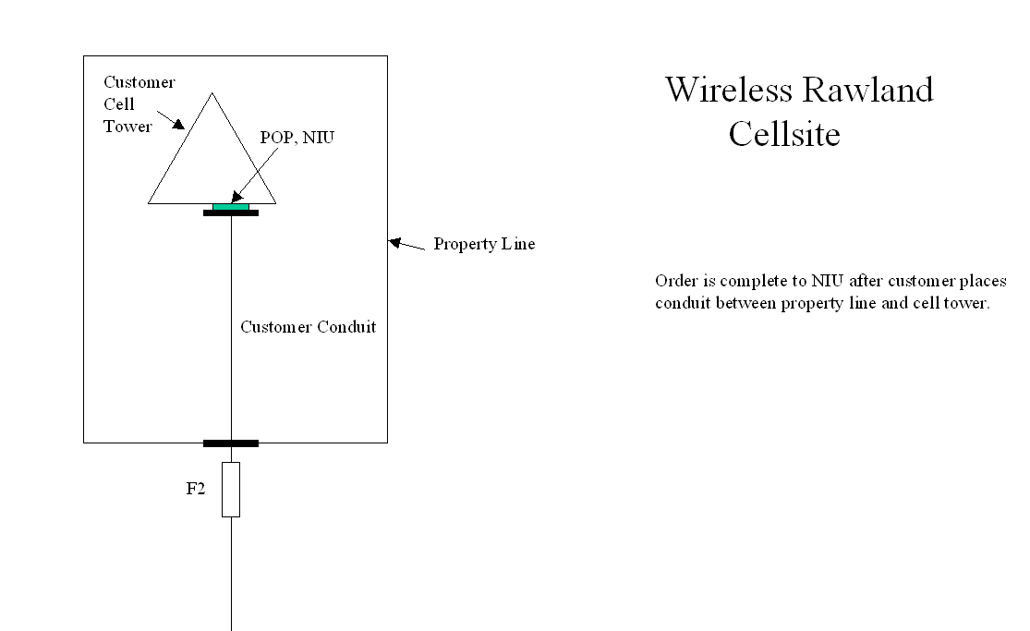

CenturyLink Central Office

CenturyLink TOAST (TELCO on a Stick)
Cell Site Build Process

CenturyLink TOAST (TELCO on a Stick)
Cell Site Build Process

“Telco on a Stick”,” Environmental Enclosure” is an environmental cabinet that can be used for Raw Land Cell Site applications that will terminate DS1 service. It does not preclude the “Raw land” site process. Use of Telco on a stick does not by pass any requirements for work behind the last pedestal. If a job is required to serve the location, a job will still be required for Telco on a stick. What Telco on a stick provides the customer is the reduction of delayed time associated with placement of the Customer Conduit.
NOTE: Telco on a Stick (TOAST) is not an option at High Voltage Sites.

The order must still show “RAWLAND” “TELCO ON A STICK” in the RMKS.

The Customer will begin this process by submitting an ASR and the same process will be followed as outlined previously in CenturyLink Cell Site Build Process. The Engineer will also determine if the site is an appropriate candidate for Telco on a stick. If it qualifies the Engineer will advise the customer as to where to place the stick and where permanent conduit will be run. The Engineer will identify the requirements, for an environmental box that will be attached to the 4X4 post the customer places on their property. The Engineer will need to inspect the placement of the stick and notify Design Engineering (CP) by updating the held/delayed order tracking system to release the order to be scheduled for Design, Test & Turn up. (As long as any other pending jobs have been completed.)

Once testing is complete to the customer location, (“NIU, stick”) the customer then accepts the service and the order are completed. The Customer is responsible to get from the “stick” to the cell tower.

Now that the order is completed and the Customer has extended to the cell tower and they decide they want to test all the way through, a maintenance “test assist” ticket needs to be opened in the repair center.

A new ASR will need to be issued to move their NIU, if the Customer wants it moved from the “stick” to the cell tower. The Customer will need to place an order to CenturyLink to move the NIU. The Service Delivery Coordinator (SDC) will need to issue the order recapping the entire circuit and put a “M” (move) action code by the Z-loc channel term and a clear remark explaining what is required . The installer will do the work and the tester will show time and material USOC’s. The Service Delivery Coordinator (SDC) will need to transfer the USOCs onto the order when it posts to bill the appropriate charges.
NOTE: Telco on a stick is an option the Customer can request. It is not a standard we use for every wireless order. Telco on a Stick is only a “temporary service” and per the Special Construction tariffs the WSP will be billed for the placement and removal of these facilities.

T
T

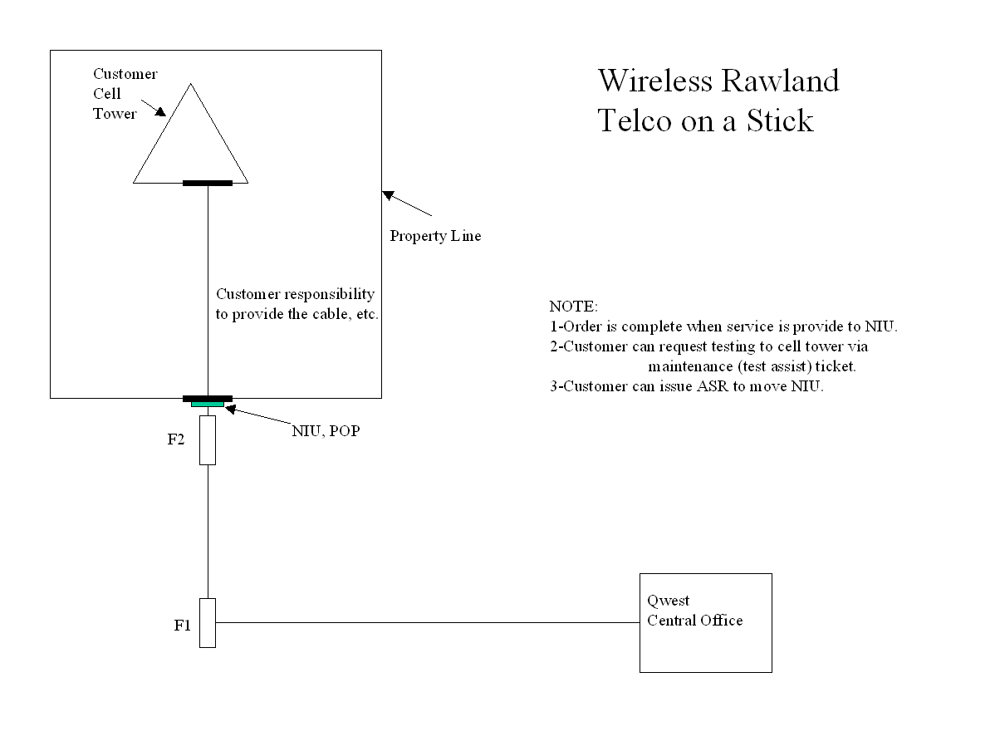

CenturyLink Central Office

Westell /

CenturyLink’s High Voltage Process

CenturyLink’s High Voltage Process

High Voltage protection may be required when a wireless cell site is located in a High Voltage Location such as substationor power plant. Attached to the grounded fence, or within the Zone of Influence of a High Voltage Location, or when the Wireless antennas are attached to a power transmission structure. See pages 29-32.
If the PCS customer is using a power transmission structure as a support for their transmitter antenna and the structure is not located within the zone of influence of an electric power station (see page29):

1. The RG31-0048 Design Information for Power Industry Channels Customer Information found at URL link http://www.centurylink.com/wholesale/pcat/wireless/forms/designinfopowerindchannel.html and RG31-0048A Design Information for PCS Channels Customer Information found at URL link http://www.centurylink.com/wholesale/pcat/wireless/forms/designinfopcschannel.html forms are required if the customer desires wireline service, or
2. The form is not required if the customer desires service on a dielectric fiber, either placed by the customer or placed by CenturyLink. This fiber may extend to a copper-to-fiber junction point 500 feet from the power structure or may extend to the central office (see page 29).

If the PCS customer is using a power transmission structure as a support for their transmitter antenna and the structure is located within the zone of influence of an electric power station (see page 30) :

- The form is required, regardless of the mode of service, unless the service is on fiber which extends to the central office. The central office end and any copper-to-fiber conversion must be located outside the electric power station zone of infuence, and that zone can only be determined through the information on the form.

If the PCS Customer locates their equipment within the zone of influence of an electric power station, regardless of configuration (see page 31 and page 32):

- The form is required, regardless of the mode of service,unless the service is on fiber which extends to the central office. The central office end of any copper-to-fiber conversion must be located outside the electric power station zone of influence, and that zone can only be determined through the information on the form.

High Voltage Location over 20,000 Volts

When CenturyLink Service is placed into a high voltage location where the Ground Potential Rise (GPR) exceeds 20,000 volts, copper facilities cannot be used. In these locations it will be necessary to use a new type of fiber optic equipment that will convert copper to fiber. This will isolate hazardous voltage to protect both facilities and personnel.

CenturyLink’s High Voltage Process continued

The USOCs to be used for copper to fiber conversion equipment, when the High Voltage Location is over 20,000 volts are:

P1QTA – CenturyLink provided HVP equipment

If the fiber optic equipment is CenturyLink provided, rates will be determined on an Individual Case Basis (ICB) and will be billed to the customer up front. There will be no month to month or contract billing for this equipment.

Billing will be determined by using the Special Construction option, found in the Special Assembly routine in AQCB (Auto Quote and Contract billing System) or the Special Construction using the BART billing process.

VPQ – Customer provided HVP equipment

If the fiber optic equipment is customer provided, there will be no month to month or contract billing for the customer provided HVP equipment.

VPQSP – Span Power for customer provided HVP equipment

When Interstate (FCC) DS1 Service, provided over metallic facilities, is connected to customer provided optical high voltage protection equipment, the Company will provide upon request, DS1 span power from the CO to the CPE electrical-to-optical converter, at the point of termination. (Span power is only available for high voltage locations, and is limited to 60ma simplex current.)

The USOC to provide DS1 Span Power is VPQSP.

The monthly rate is $28.00. There is no nonrecurring charge.

When providing Central Office Power to DS1 service, the following NCI codes will apply:

End User Location 04DU9.1K
Carrier POP 04DS9.1BN
Wireless Location 04DJ9.*

*Any Valid entry

Tasks for Raw Land with High Voltage Cell Sites

TASK DAYS RESOURCE

CUSTOMER
Submits request for service at High Voltage Location 0 Customer
Using form (RG31-0048)

BUSINESS OFFICE 1 Business Office
Determines High Voltage Protection option (Customer or CenturyLink provided)
Mails, Faxes or e-mails form (RG31-0048) to customer

CUSTOMER 1 Customer
Completely fills out the follow up (RG31-0048) form

ELECTRICAL PROTECTION ENGINEER (EPE) 7 EPE
Compares form (RG31-0048) to existing site
Documentation and determines the Electrical Protection needed for the site.

SITE VISIT WITH THE ENGINEER 15 Engineer
Site Visit scheduled w/Customer/Property Owner
Engineer meets with the Customer/Property Owner
Site Survey Completed
Compile Notes, Site Plan and forward to Electrical Protection Engineer (EPE)

VISIT INFORMATION SENT TO OSP Engineering
Engineer Job(s) and Establish Ready for Service (RFS) Date 15 /OSP TP/QRE
RFS date = 45 business days after the receipt of site visit information
Determine if Special Construction is involved (if yes – complete BART billing process; if no – Engineer job)

BART BILLING
Business Office Business Office
Bill sent to customer (customer has 30 days to pay the bill)
Payment received and engineering notified – proceed with funding approval and design

Estimated Engineering Completion (EEC) Date = 15 days from site visit)
RFS Date = EEC + 30 Business Days
Due Date = EEC + 41 Business Days
Job Issued-Prints to Construction Field/OSP DE/QRE

Tasks for Raw Land with High Voltage Cell Sites continued

CONSTRUCTION ACTIVITY TO BEGIN 30
CenturyLink Construction Construction

IMPLEMENTATION 11
Designed Services Design DS
Central Office Wiring/Testing DS
Dispatch Technician DS
Plant Test Date (PTD) Testing DS
CUSTOMER ACCEPTANCE Customer

TOTAL DURATION 80 Days (Business Days)

- NOTE: To meet 80 Business Days, customer conduit must be in and inspected

- NOTE: Underlined portions of timeline represent customer obligations and stop the clock until customer issues are resolved.


NETWORK RELIABILITY and
OPERATIONS CENTER

Timothy L. Conser Phone (303) 707-5616
Member Technical Staff – Electrical Protection FAX (303) 707-9041
700 W. Mineral Avenue, Mail Stop MT g 22.31 Pager (800) 946-4646 PIN 1720190
Littleton, Colorado 80120 Email tconser@centurylink.com

April 23, 2001

Memorandum to File:

RE: Temporary powering of Cell Sites with Generators.

CenturyLink will provide service at PCS/Cellular sites only after the local municipality has issued a permit and approved the electrical installation and grounding of the site. When the permanent commercial power is delayed by the local distribution Power Company, due to scheduling, the customer may turn up their site, using a temporary, approved generator; however, the customer must provide a signed off electrical permit before CenturyLink will provide service.

The temporary generator must meet all local, state, and National Electric Code (NEC) standards for grounding and installation for separately derived systems prior to CenturyLink providing service. If you have any questions, please contact me.

Respectfully,
Tim Conser
Lead Technical Support Engineer
Electrical Protection

August 24, 2000

Dear Wireless Customer,

In order to better align CenturyLink processes with technical specifications and provide you with options for reliable service, the following standards are being recommended for your use at High Voltage Locations.

As you are aware, Industry standards require that you provide CenturyLink with:

- A place to terminate our equipment (i.e. telco room, 4’x8’x3/4 inch plywood backboard, etc.)
- Grounding to the common grounding network (i.e. #6 copper ground wire to power grounding electrode)
- Conduit to the public right of way
- Local Powering (i.e. 120 volt, 20 amp, AC, double duplex outlet)

The local powering is your responsibility at High Voltage locations because the Network Channel Terminating Equipment and Network Interface Unit line powering is blocked by the High Voltage equipment that is required at these locations.

When you provide the standard 120 volts AC, it is recommended that an Uninterruptible
Power Supply system be installed and maintained for service continuity. If commercial power is provided without a backup system, the service will fail when commercial service is lost and may require a service call when power is restored.

You may choose to install a separate source of power such as a – 48 volt DC system. CenturyLink is willing to work with you to ensure we are tied to the same power source to ensure reliability of service. Again, if the power source is provided without a backup system the service will fail when commercial service is lost and may require a service call when power is restored.

It is also a requirement that all future NIU’s be located in the cell site shelter as a safety precaution. The goal of locating the NIU in the shelter is to eliminate the need for your personnel to access the High Voltage common equipment.

If you have any questions regarding the powering requirements, please contact Tim Conser, TEC 55 Consultant – Electrical Protection, on 303-707-5616.

Sincerely,

Phil Williams
Vice President - Specialized Markets
CenturyLink Wholesale Major Markets

RG31-0048
Rev (9-98)

DESIGN INFORMATION FOR POWER INDUSTRY CHANNELS

CUSTOMER INFORMATION
(Use one form for each service order requested. See item Service Classification.)

Customer 1.

Location A – Station Name  2. | Address  3. | Tel. No.  4.
Location B – Station Name  5. | Address | Tel. No.

GROUND POTENTIAL RISE (GPR) FAULT DATA
EXAMPLE ONLY
Fault Circuit X/R Ratio | Earth Return Fault Current | Grid Impedance | Grid Area | Ground Potential Rise
Location A  6. | AMPS  7. | OHMS  8. | SQ. FT  9. . | VOLTS  10.
Location B | AMPS | OHMS | SQ. FT. | VOLTS
CHANNEL TYPE
Existing Service – New Request – Future Needs)
11. | EXISTING | NEW | FUTURE
2-W Phone, 2 W-Trunk, DC Circuits, ISDN (Type 1 Service) | 12. | 13. | 14.
Tie Line, Trunk, Radio Remote, Etc. (Type 1 Service)
2-Wire/4-Wire (Circle 1)
Digital Data Service (Type 1 Service)
Pilot Wire Relay (Type 2 Service)
D.C. Tripping (Type 2 Service)
A.C. Tone w/o Signaling and High Capacity(DS1)
Telemetering, SCADA Data (Type 3 Service)
High Capacity Digital (DS1) (Type 3 Service)
Audio Tone Protective Relaying (Type 4 Svc)

ENGINEER OR REPRESENTATIVE
(Must have attached sketch of the power station showing present and future power transmission routes.)
Signature/Date  15. | Tel. No. | Address

TELEPHONE COMPANY INFORMATION
Service Order No.  16. |  | Due Date | Circuit Number |  |  | Special Billing Number
Account Representative |  |  | Tel. No. | Send to Electrical Protection Engineer
Electrical Protection Engineer-Signature/Date |  |  | Tel. No. | Address
Protection Required | 300 V Pk Point  Distance FT |  | USOC | Type |  |  | Quantity
Location A
Location B
Loop Facility Designer |  |  | Tel. No. |  | Job Number

INSTRUCTIONS FOR RG31-0048

- Customer Name

- Power Station Name

- Power Station Address

- Power Station Phone Number

- Other end of requested service if applicable. Use additional forms for multi-point circuit locations.

- X/R (inductive reactance to resistance) ratio for worst cast fault current.

- Worst cast fault current passing through the grid resulting in a Ground Potential Rise (GPR).

- Grid impedance in relation to remote earth.

- Area covered by station ground grid in square feet.

- Ground Potential Rise (GPR) in rms volts.

- Check appropriate boxes for requested service.

- Existing number of services of each type now at the location.

- Number of services of each type being requested.

- Projected future services of each type expected at this location. This and items 12 and 13 are needed when a new entrance facility or High Voltage Protection upgrade is required.

- A signature and date is required from the engineer providing the information or a representative of the company requesting the service. Include telephone number and address of that person.

- Make no entries in this area.

RG 31-0048-A
REV 10/98

DESIGN INFORMATION FOR PCS CHANNELS

CUSTOMER INFORMATION
(Use one form for each service order requested. See item service classification)
Customer
EXAMPLE ONLY

Location Station Name | Address | Tel No.

Ground Potential Rise (GPR) Fault Data
Fault Circuit X/R Ratio | Earth Return Fault Current (RMS AMPS) | Engineer Signature, Date, Firm, Tel. No.

Grid Impedence (OHMS) | Grid Area (Sq. Ft.) | Engineer Signature, Date, Firm, Tel. No.
Ground Potential Rise (RMS)

Volts

PE Stamp or Number

Service Classification
(Definitions of type, Class and USOC are on Reverse of this sheet. If Class C is requested, leave Class item blank)
Location | Type | Class | USOC

Channel Type (Existing Service, New Request, Future Needs | Existing | New | Future
2-W Phone
High Capacity Digital (DS1) – Type 3 Service

Telephone Company Information
Service Order No. |  | Due Date | Circuit Number |  |  | Special Billing Number
Account Representative |  |  | Tel. No. | Send to Electrical Protection Engineer
Electrical Protection Engineer-Signature/Date |  |  | Tel. No. | Address
Protection Required | 300 V Pk Point  Distance FT |  | USOC | Type |  |  | Quantity
Location A
Location B
Loop Facility Designer |  |  | Tel. No. |  | Job Number

DEFINITIONS

CLASS A OR B SERVICE

SERVICE TYPE AND PERFORMANCE OBJECTIVE CLASSIFICATION/USOC*

TYPE 1, CLASS B SERVICE (Phone, tie lines, trunks, radio control, DC alarms, telegraph, DDS)
All circuits used for talking plus DC telemetering and telegraph.
Services which require both AC and/or DC transmission and which can tolerate momentary interruptions during a
power fault. (Must function before and after a power fault.)
USOC
2 wire HVC
#4 wire HVA
4 wire HVD

TYPE 2, CLASS B SERVICE (DC Tripping, Pilot Wire Relay (Class A performance not available)
Normally a metallic cable pair end to end, but it can be a DC telegraph channel. (Metallic facilities are offered only
where existing facilities and operating conditions permit).
Services which require both AC and DC transmission and which can tolerate momentary interruptions during a power
fault. (Must function before and after a power fault.)
USOC
2 wire HVE
#4 wire HVB

TYPE 3, CLASS A SERVICE (Data, Telemetering, SCADA)
Critical non type 4 circuits, which require class A performance.
Services for AC transmission only, which cannot tolerate even momentary interruption. (Must function before, during,
and after a power fault.)
USOC
2 wire HVF
4 wire HVG

TYPE 3, CLASS B SERVICE (Data, Telemetering, SCADA)
All tone signals 300 HZ to 5 MHz and High Capacity Digital (DS1 rate).
Services for AC transmission only, which can tolerate momentary interruptions during a power fault. (Must function
before and after a power fault.)
USOC
2 wire HVH
4 wire HVJ

TYPE 4, CLASS A SERVICE (Audio Tone Protective Relaying)
Protective Relaying or Transfer Tip only. (Voice Grade 12 when interlata.)
Services for AC transmission only, which cannot tolerate even momentary interruption. (Must function before, during,
and after a power fault.)
USOC
2 wire HVK
4 wire HVL

#Services limited to a maximum ground potential rise (GPR) of 4.0 KV RMS-11 VS. (Refer to Electrical Protection
Engineer before selecting.)

CLASS C SERVICE

Interruptible service performance (can tolerate visit to restore service).

If ground potential rise (GPR) is less than 1000 volts peak-asymmetric, no protection is required and Class C service may
be requested. Electrical Protection Engineer shall determine this.

*TYPE of service refers to circuit usage.
CLASS of service refers to reliability of HVP during a power fault.

TECHNICAL PUBLICATION

Technical characteristics for High Voltage Protection (HVP) can be found in the CenturyLink Technical Publication, Special High Voltage Protection, 77321 http://www.centurylink.com/techpub/77321/77321.pdf

Electrical Protection Engineers

Tim Conser (303) 707-5616 CO, MN, ND, SD, WY

Terry Avery (503) 251-7041 IA, NE, OR

Scott Miyoshi (360) 478-4415 ID, MT, WA

Larry Young (520) 292-7561 AZ, NM, UT

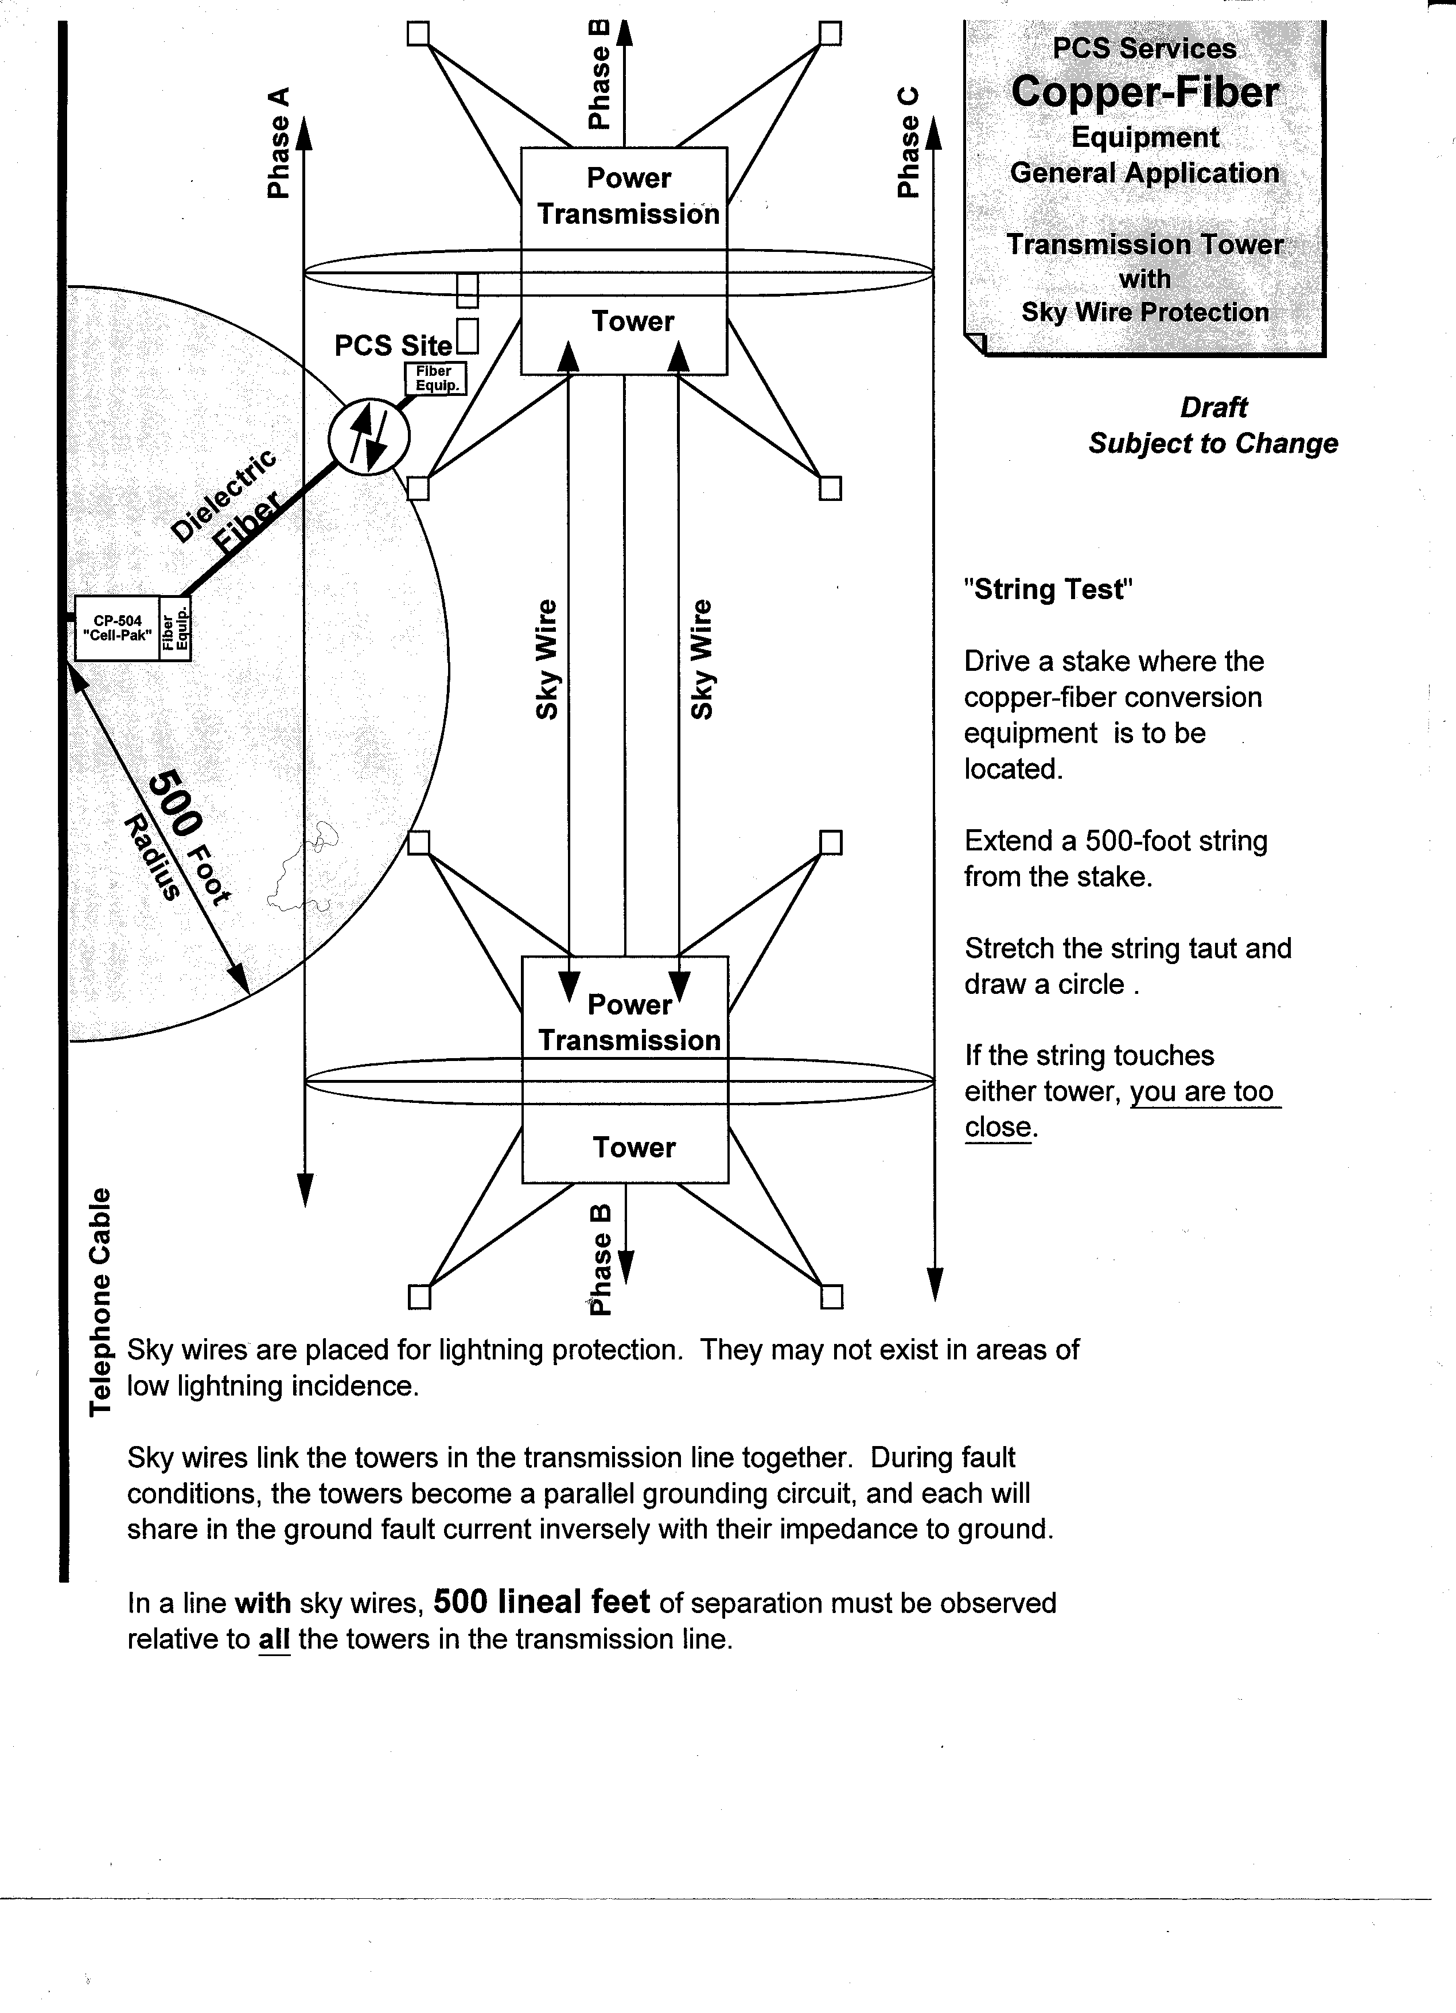
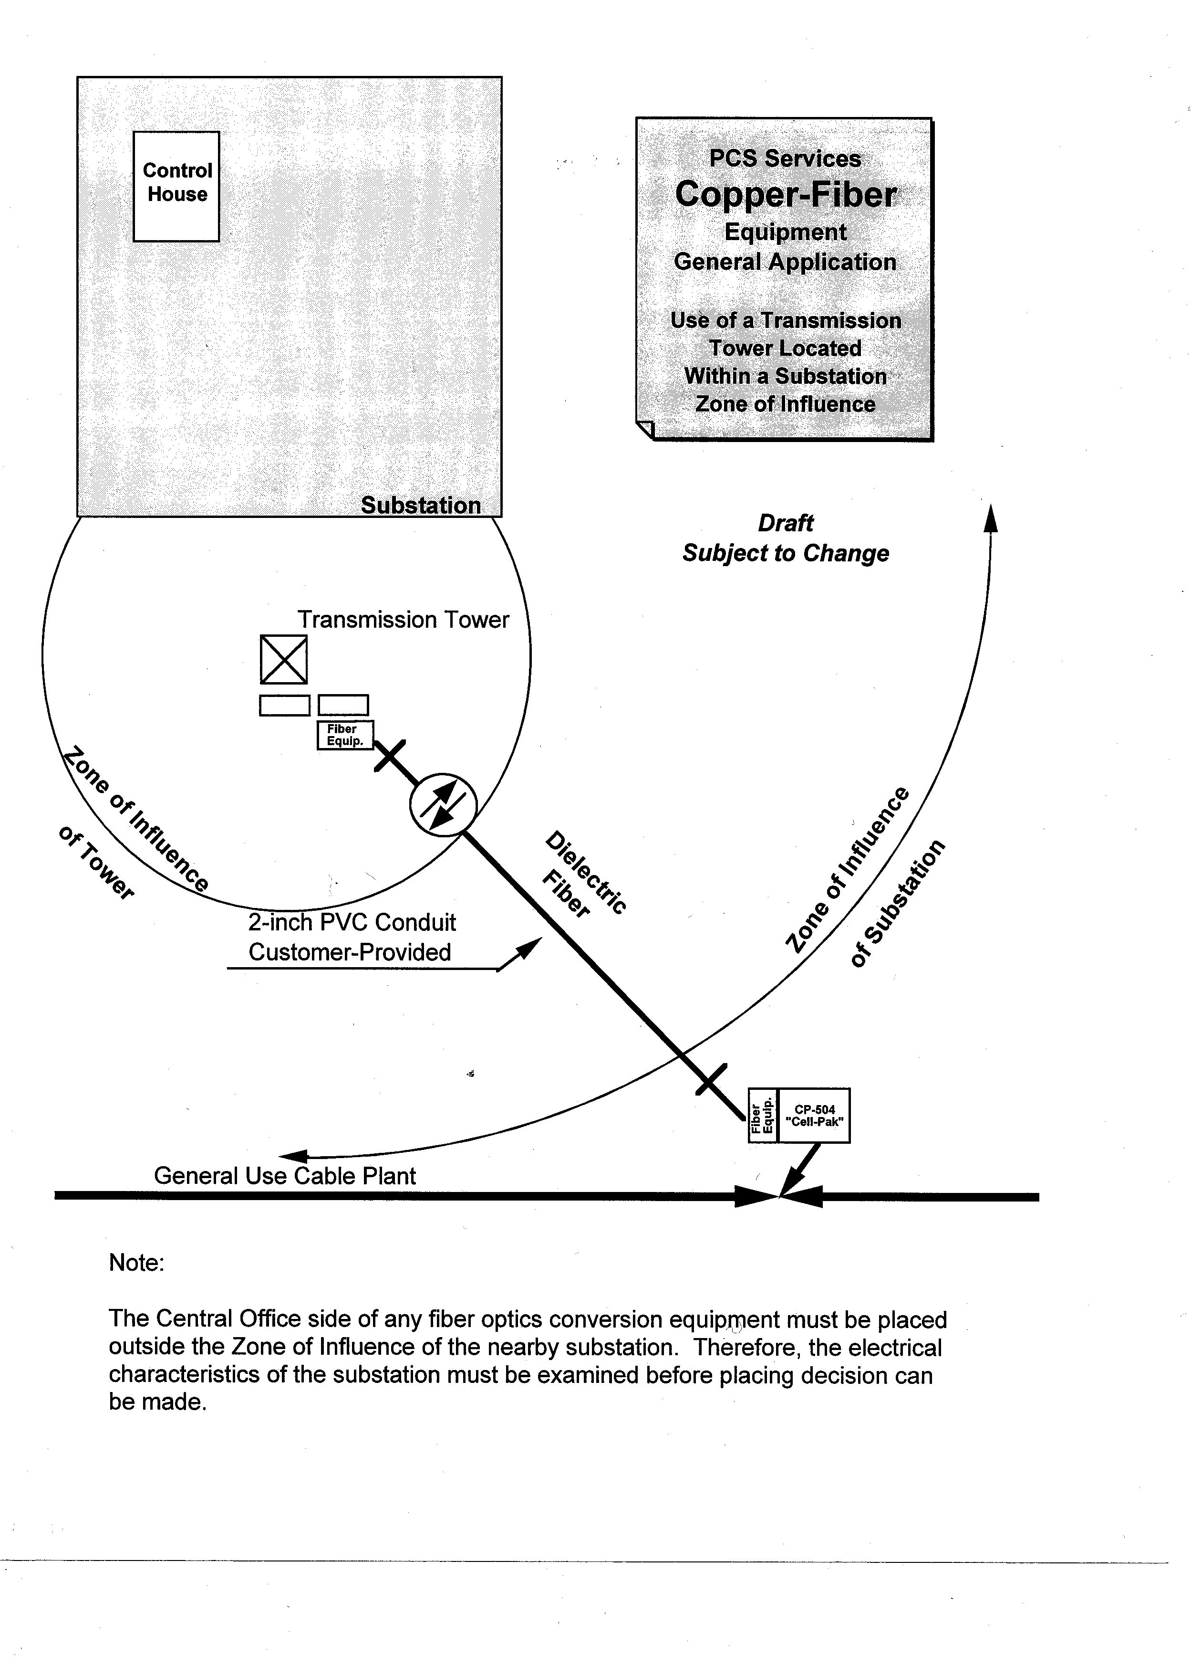
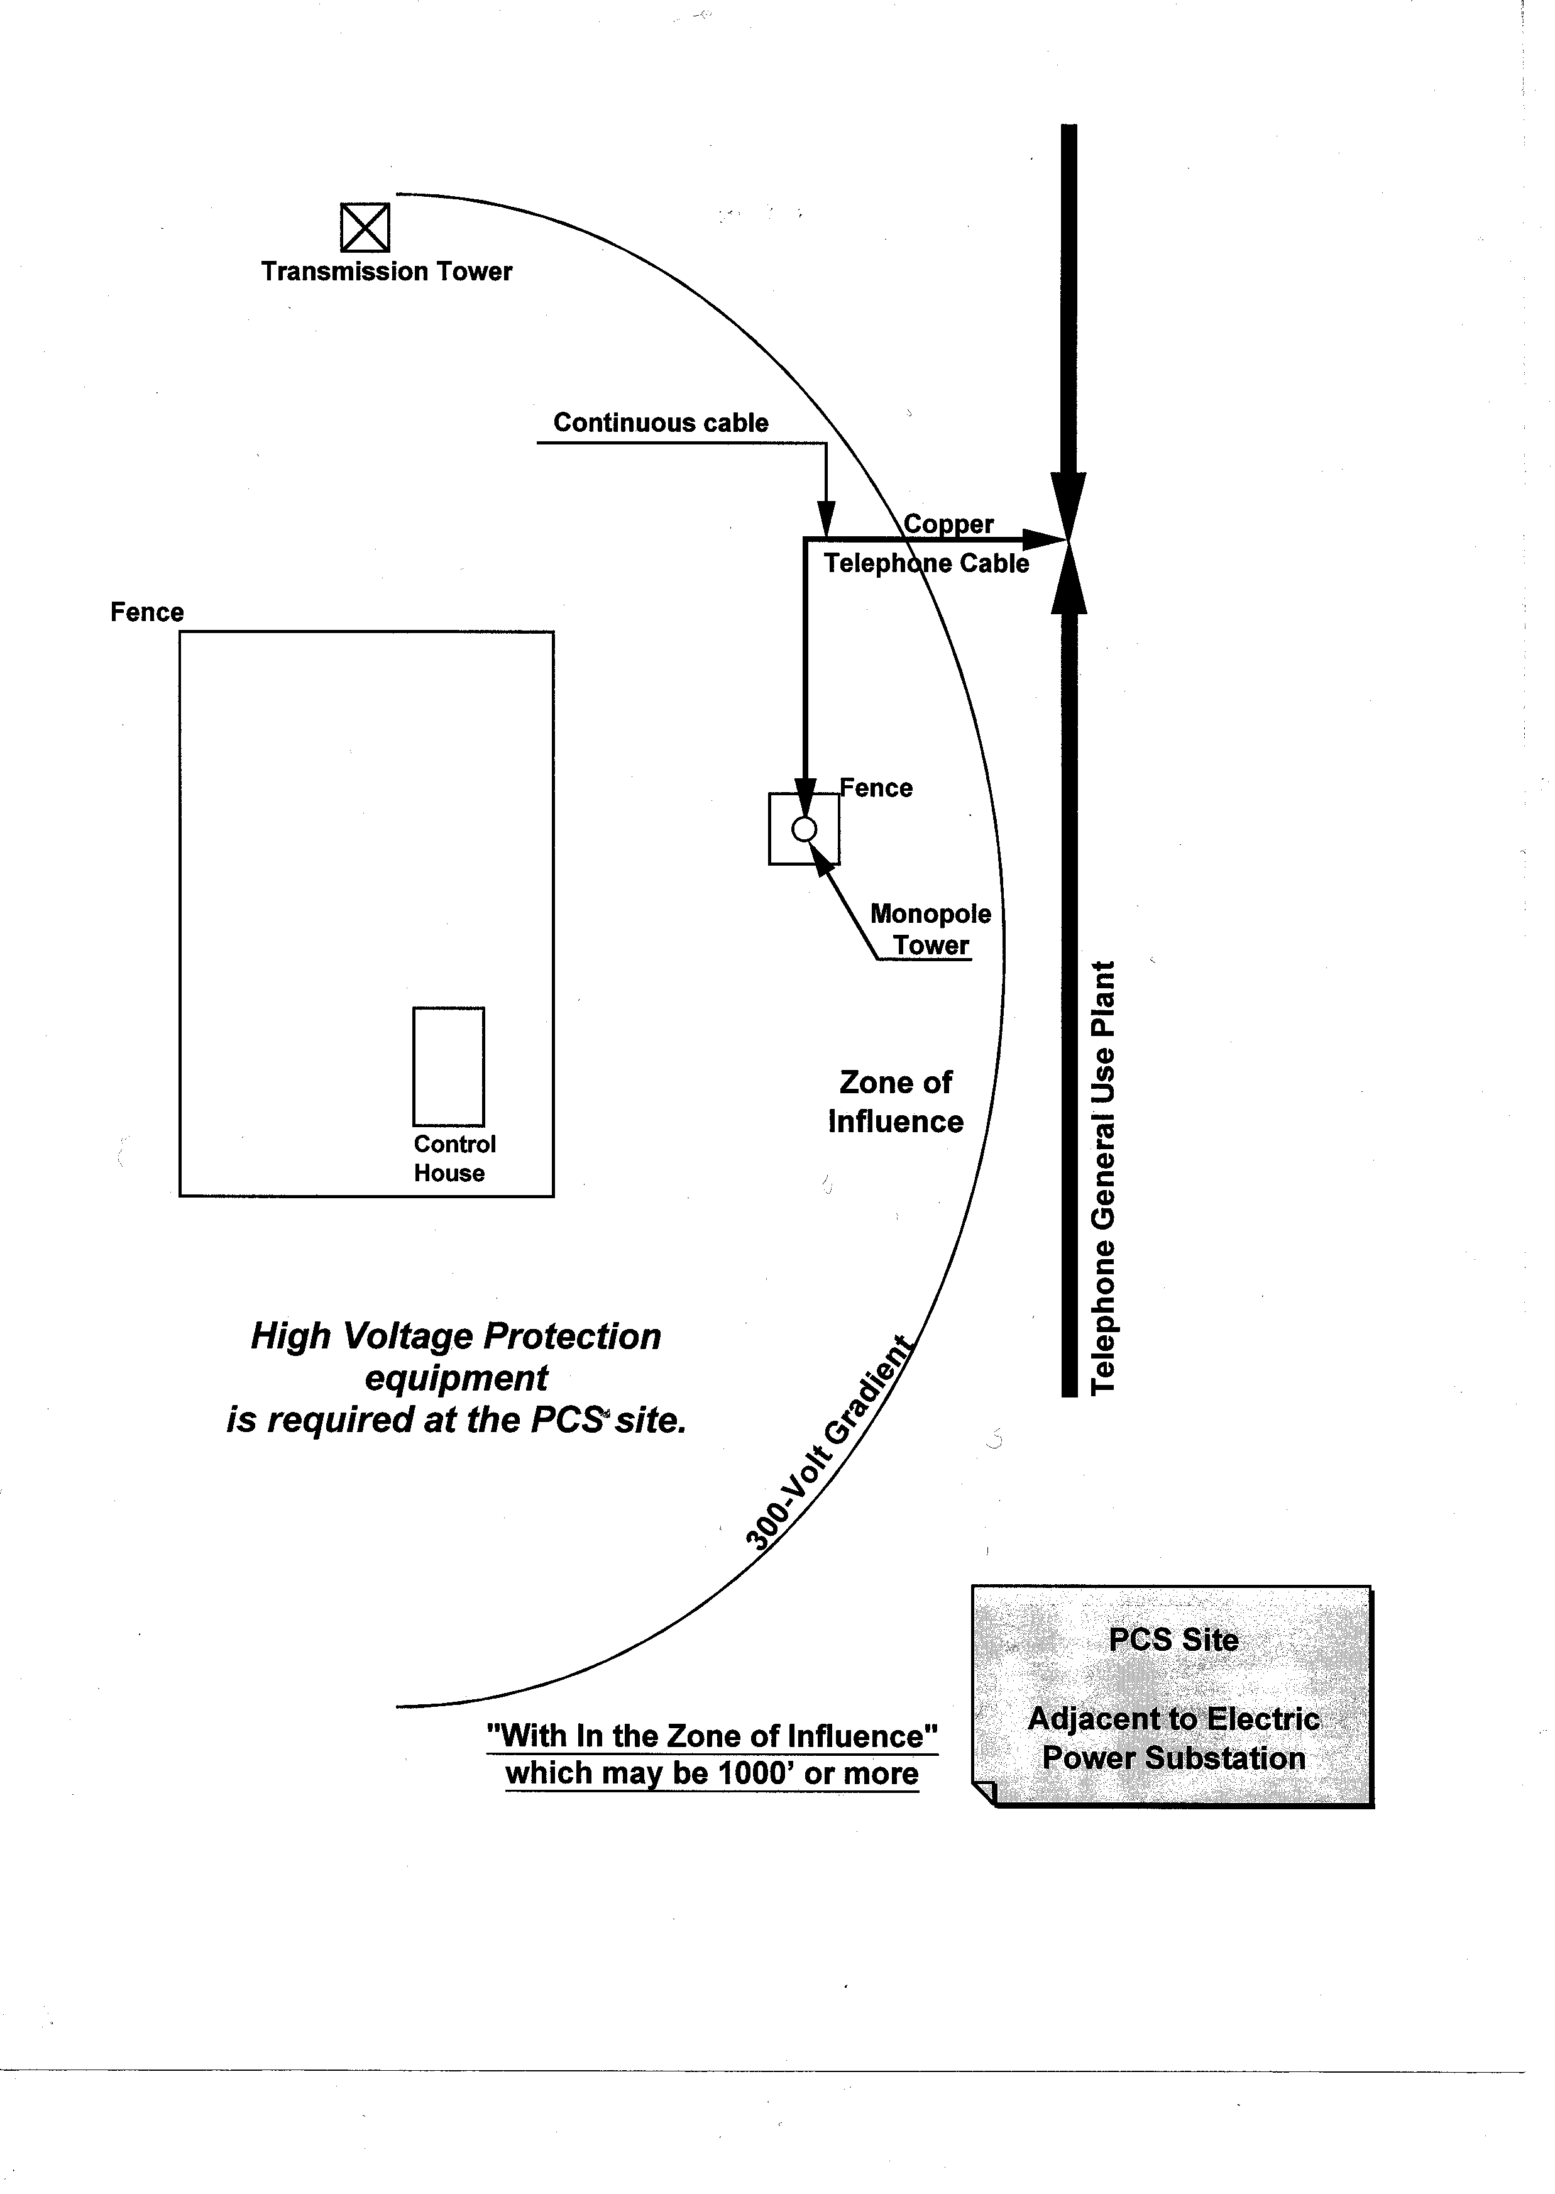
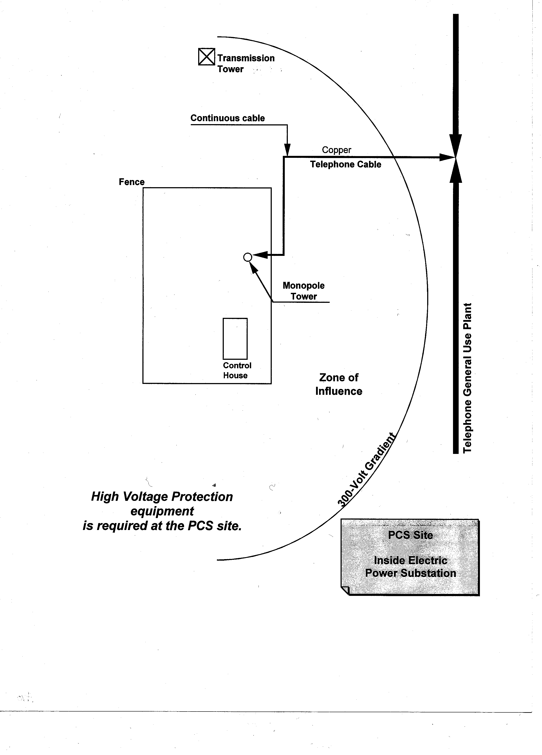

CENTURYLINK Pre-Build Provisioning Process

CENTURYLINK Pre-Build Provisioning Process

For Individual Raw Land Cell Sites

CenturyLink offers a Pre-Build process for engineering, constructing and cabling necessary facilities to raw land sites.

This process is referred to as Cell Site Raw Land Pre-Build Process and is available to customers needing to build facilities prior to issuing an ASR. Following are the conditions under which Pre-Build is offered:

Raw land is defined as any location where the customer currently does not have services with CenturyLink even if other customers have CenturyLink service at that location.

Customer agrees to pay all engineering and construction charges through the Special Construction billing process.

The Document, which triggers this process, is a Letter of Request (LOR) - Request for Cell Site Raw Land PreBuild with Applicant’s Installation of Conduit signed by the customer and sent to Sales. A working copy to the LOR Request for Cell Site Raw Land PreBuild with Applicant’s Installation of Conduit form is available at:http://www.centurylink.com/wholesale/pcat/wireless/forms/csrawlandprebuild.html

The following are the critical steps that must be followed by CENTURYLINK and the Wireless customer:

- Customer downloads the Request For Cell Site Raw Land Pre-build With Applicant’s Installation of Conduit form from CenturyLink web site: http://www.centurylink.com/wholesale/pcat/wireless.html
- Customer must fill out the request indicating this is “raw land”. The request must also contain a legal address, contact name and phone number, and any unique site characteristics such as high voltage or multiple users.
- Customer fills out, signs and emails the Request For Cell Site Raw Land Pre-build With Applicant’s Installation of Conduit to their Service Manager
- When Service Manager receives the signed request, they submit it to appropriate Engineer.
- A CenturyLink Engineer will contact the customer to schedule the site visit.
- At the time of the site visit (or earlier if available), the customer will provide the site plans to the engineer. If the site is identified as High Voltage, the appropriate form (Form 48) will be required. If the site is to be served by 25PR cable, a Letter of Intent will need to be signed by the property owner. The time frame and point of feed for the conduit placement will be determined.
- CenturyLink Engineer will calculate the Special Construction Charges
- Customer receive a Special Construction bill
- Once payment is received CenturyLink will move forward on Engineering and Construction

CENTURYLINK Pre-Build Provisioning Process continued

- After the initial Cell Site visit, CenturyLink will build facilities to the Cell Site in preparation for delivering service, unless a written cancellation notice of this LOR is received by the CenturyLink Engineer.
- If Applicant cancels this Request for Cell Site Raw Land Pre-build, Applicant shall be liable for any and all costs incurred by CenturyLink through the date of cancellation. These costs shall include, but not be limited to, the non-recoverable costs of engineering and design, labor, supervision, transportation, rights-of-way and other associated costs at CenturyLink's prevailing time and material rates. Customer will receive a Special Construction bill.
- After the customer’s conduit is placed, the customer must notify CenturyLink to schedule an inspection. Work cannot proceed to complete the order until this notification has been made.
- CenturyLink will have 30 days after the conduit inspection to complete its construction work.

All time commitments set forth herein are dependent upon: (a) CenturyLink's receipt from Applicant of an acceptable validated address; (b) Applicant's securing all necessary permits, zoning exceptions or other zoning requirements, permissions, easements of any kind, rights of way and licenses; (c) Applicant's completion of site readiness; (d) Applicant's completing all structures necessary for installation and operation of the CenturyLink services; (e) CenturyLink's receipt of a signed Letter of Intent Service Facility Configuration & Ownership (form RG29-0102); and (f) Applicant's satisfying all contingencies within its control that could lead to delays

See also the Timeline for Individual Raw Land Cell Sites, Letter of Intent and High Voltage form.

Note 1: Provisioning facilities for specific service will not be reserved until a valid service order is received from the customer.

Note 2: This Pre-Build Process for High Voltage Sites requires the High Voltage issues to be resolved and design determined prior to the process beginning. Some designs may require service orders, due to the equipment CenturyLink orders is based on service order USOCS.

Timeline for Individual Pre Build Process

TASK DAYS RESOURCE
SERVICE MANAGER RECIEVES PREBUILD REQUEST 1

SITE VISIT WITH THE ENGINEER 15
Site Visit scheduled w/Customer/Property Owner* Engineer
Engineer meets with the Customer/Property Owner* Engineer
Site Plan, Letter of Intent and Conduit Ready Date from Customer* Customer
Site Survey Completed Engineer
Compile Field Notes, Site Plan and forward to create cost quote and
send to Special Construction Group for Billing Special Construction
Customer receive a Special Construction bill
Once payment is received CenturyLink will move forward on
Engineering and Construction 30 Customer

CUSTOMER CONDUIT JOB COMPLETE * Customer
Customer must notify Engineer & SDC when complete

VISIT INFORMATION SENT TO DSE 4
Engineer Job and Establish Ready for Service (RFS) Date Engineer
Job Issued-Prints to Construction* Engineer

Estimated Engineering Completion (EEC) Date =

Customer Conduit Ready Date* (min.15 days from site visit)
RFS Date = EEC + 27 Working Days*
Due Date = EEC + 36 Working Days*

CONSTRUCTION ACTIVITY TO BEGIN* 27
CENTURYLINK Construction Construction

Inventory Complete and loaded into CENTURYLINK data bases FS

CUSTOMER ACCEPTANCE Customer
TOTAL DURATION 77 Days (Business Days)

- NOTE: To meet 77 Business Days, customer must submit Special Construction payment and their conduit is in and inspected
NOTE: CenturyLink will engineer and order material while the conduit is being built.

FORMS

FORMS

LOR Form

A working copy of the Cell Site Raw land Pre-Build Form is available at the following URL link:

http://www.centurylink.com/wholesale/pcat/wireless/forms/csrawlandprebuild.html

Letter of Intent (RG29-0102) Forms

Working copies of the Letter of Intent (RG29-0102) state specific forms are available at the following URL link:

http://www.centurylink.com/wholesale/pcat/wireless/forms/letterofintent.html

Structural Specifications (RG 29-0160) Form

A working copy of the Structural Specifications (RG 29-0160) form is available at the following URL Link:

http://www.centurylink.com/wholesale/pcat/wireless/forms/structuralspecification.html

High Voltage RG31-0048 Form

A working copy of the High Voltage RG31-0048 form is available at the following URL Link:

http://www.centurylink.com/wholesale/pcat/wireless/forms/designinfopcschannel.html

