

CenturyLink™ Maintenance and Repair Invoice Tool
User’s Guide

Software Release: 5.0
Release Date: September 18, 2014

Document Information

Version Notice
Document Date | Software Release | Document Version
June 2003 | 1.0 | 1.0
December 2003 | 2.0 | 2.0
February 2004 | 3.0 | 3.0
November 2013 | 4.0 | 4.0
September 2014 | 5.0 | 5.0

Change Log
Revision Date | Document Version & Software Release | Description
11/22/2013 | 4.0 | - Updated the URL for CLEC Maintenance and Repair Invoice Tool.  - Rebranded and changed to CenturyLink Standard Template.
8/22/2014 | 5.0 | - Updated information as CEMR application is decommissioned  - Updated Screenshots for new app CEMR-MTG

Copyright
© 2014 CenturyLink, Inc. All Rights Reserved.

Trademarks
CenturyLink and the CenturyLink logo are trademarks of CenturyLink, Inc. The trademarks contained in this document are the property of their respective holders.

Document Location
You can obtain the latest version of this document at http://www.centurylink.com/wholesale/network/repairinvoiceguide.html

TABLE OF CONTENTS

Document Information 2
Overview 4
Getting Started 4
Access the Invoice Information Tool 4
The Login Screen 4
Log On to the Application 4
Searching for Repair Invoices 6
Search for All Invoices of a Specific Type 6
Search for Invoices Based on Specific Criteria 7
Reviewing Repair Invoices 8
Designed Services Sample Invoice 8
Non-designed Services Sample Invoice 9
Exporting and Printing Invoice Reports 11
Export a Report 11
Print a Report 12
Sorting and Filtering the Data 13
Getting Technical Support 13
Appendix A: Circuit ID Format Tutorial 14
Serial Number Circuit ID Formats 14
Telephone Number Circuit ID Formats 15
Carrier Facility Circuit ID Formats 16
Message Trunk Circuit ID Formats 17

CLEC Maintenance and Repair Invoice Tool User Guide
The required browser for this application is Internet Explorer IE version 8.0 and 9.0. If you are using another browser, the system may not operate as stated in this user guide.
Overview
The CenturyLink CLEC Maintenance and Repair Invoice Tool User Guide (MRIT) was developed to provide the information required for accessing and using the Maintenance and Repair Invoice Tool application.
The CenturyLink CLEC Maintenance and Repair Invoice Tool provide current CenturyLink repair invoice information for your company.
Important: Invoice information for Designed Services and Non-designed Services is available approximately two weeks after the trouble has been cleared.

Getting Started
In this section:
- Access the Invoice Information Tool
- The Login Screen
- Log On to the Application

Access the Invoice Information Tool
To find the CLEC Maintenance and Repair Invoice Tool, enter this URL into your browser address field: http://mrit.centurylink.com/mrit. The system displays the invoice information tool login screen.
For an explanation of the buttons on the screen and to log on to the tool, see The Login Screen and Log On to the Application, respectively.

The Login Screen
The application login page contains five buttons:
Provides Wholesale Help Desk contact information.
Opens Wholesale Products & Services pages, where CLECS can Download the User Guide for MRIT.
Closes the application.
Logs in to the application.
Erases the user name and password you entered so that you can enter it.

Log On to the Application
To log on to the tool, at the Login screen, enter your CEMR or CEMR-MTG user name and password. The system displays a search screen:
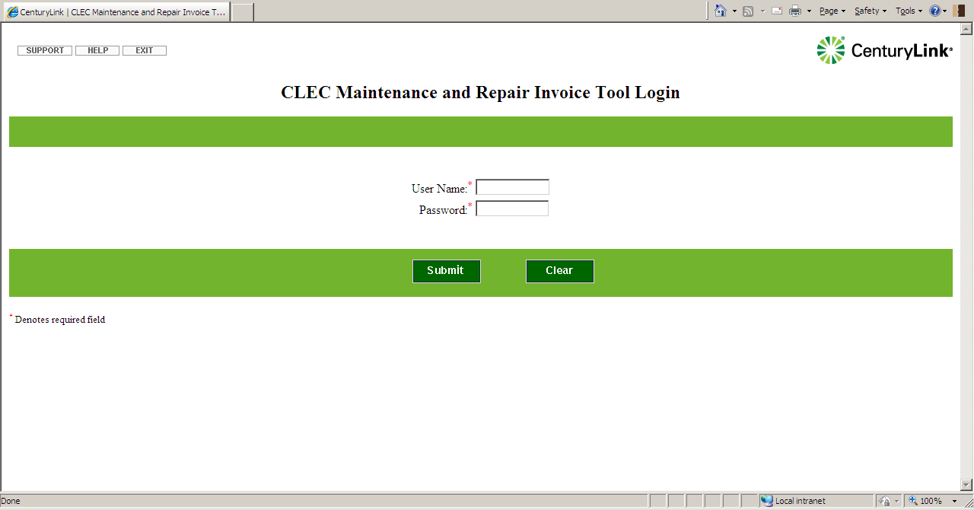
For a description of this screen and steps for searching for invoices, see Searching for Repair Invoices.
If your logon is unsuccessful, the system displays an invalid logon message and provides a link back to the login window. Adjust your user name and password, and click the button to log in.

Searching for Repair Invoices
When you log on to the application, the system displays a Search window. From this screen, you can search for repair invoices based on several criteria, however, you must always choose either Designed or Non-designed invoices to begin your search.
Important: Invoice information for Designed Services and Non-designed Services is available approximately two weeks after the trouble has been cleared.
In this section:
- Search for All Invoices of a Specific Type
- Search for Invoices Based on Specific Criteria

Search for All Invoices of a Specific Type
To find all Designed or all Non-designed invoices, follow these steps:
Log in to the application using your CEMR-MTG user name and password. The system displays the Search window.
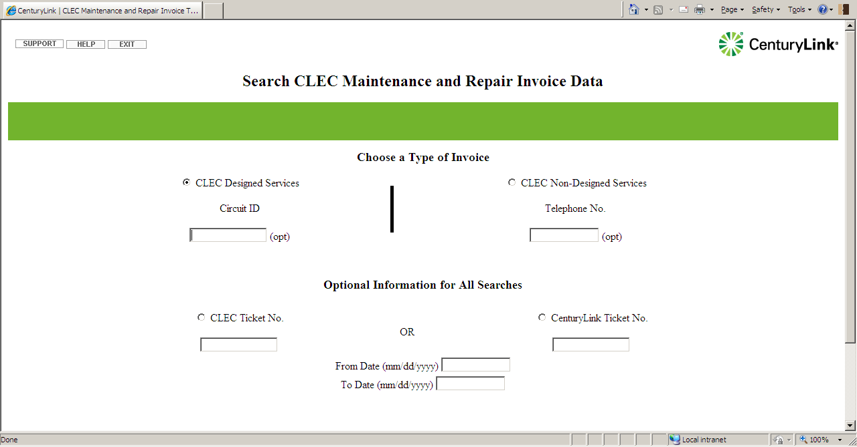
Click the appropriate radio button to choose Designed or Non-designed invoices.
Click the button to begin the search. The system displays all invoices of the type you chose.
Important: Invoice information for Designed Services and Non-designed Services is available approximately two weeks after the trouble has been cleared.
To conduct a new search, click the button in the top navigation bar. The system displays the Search window in order for you to enter new criteria.
DO NOT use the browser Back button to return to previous screens. Instead, use the buttons in the top left navigation bar, or from the report screen, use the Previous Page and Next Page buttons.

Search for Invoices Based on Specific Criteria
To find invoices by specific criteria, follow these steps:
Log in to the application using your CEMR-MTG user name and password. The system displays the Search window.
Click to choose Designed or Non-designed invoices.
Enter the criteria you want to use for the search. All criteria are optional, however, if you chose Designed invoices, you can search on circuit ID, but not telephone number. If you chose Non-designed, you can search on telephone number, but not circuit ID.
Important: The characters in the circuit ID must be exact. No fuzzy logic exists to reconcile circuit id fragments. All digits are treated as characters and have value associated with them (e.g. leading zeroes are treated as a valid part of the circuit ID). For more information on circuit ID formats, see Appendix A Circuit ID Format Tutorial.
Click the button to begin the search. The system displays the appropriate invoices.
Important: Invoice information for Designed Services and Non-designed Services is available approximately two weeks after the trouble has been cleared.
To begin again, click the button to clear all selections. To conduct a new search, click the New Search button in the top navigation bar. The system displays the Search window in order for you to enter new criteria.
DO NOT use the browser Back button to return to previous screens. Instead, use the buttons in the top left navigation bar, or from the report screen, use the Previous Page and Next Page buttons.

Reviewing Repair Invoices
Important: The repair invoices you display with the CLEC Maintenance and Repair Invoice Tool are not bills. Please do not pay for any services based on these invoices. Instead, wait to be billed before paying.
To display your invoices, you must enter search criteria in the Search window and click the Submit button. (For information about searching, see Searching for Repair Invoices.)
In this section:
- CLEC Designed Services Sample Invoice
- CLEC Non-designed Services Sample Invoice
Important: Invoice information for Designed Services and Non-designed Services is available approximately two weeks after the trouble has been cleared.

Designed Services Sample Invoice

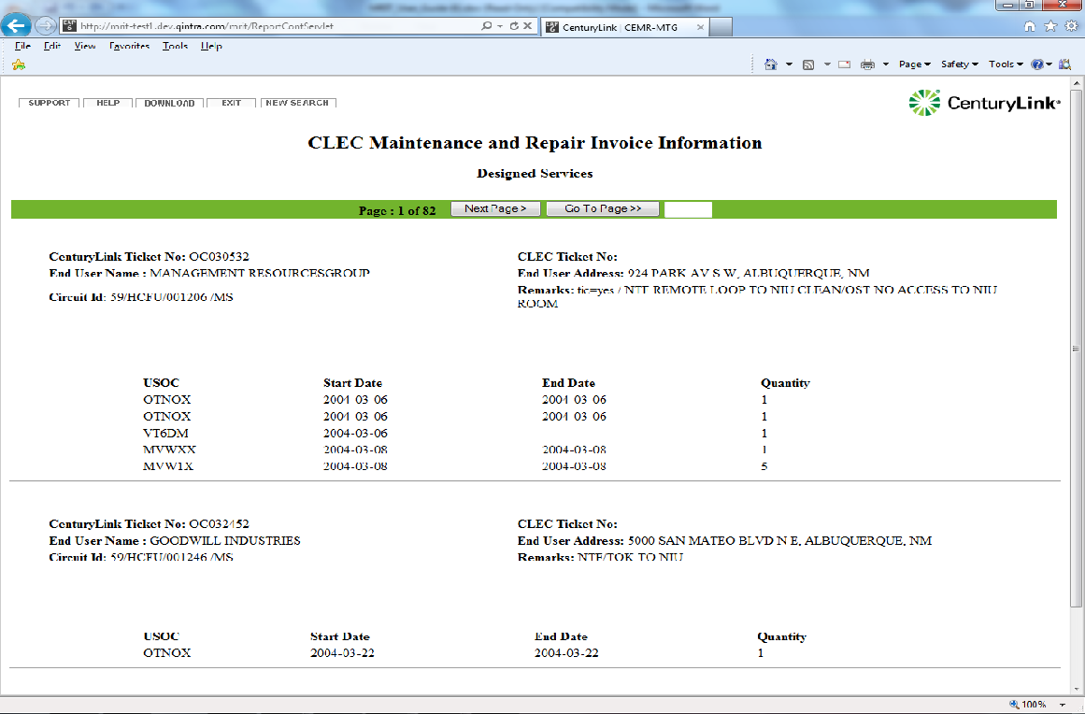
DO NOT use the browser Back button to return to previous screens. Instead, use the buttons in the top left navigation bar, or from the report screen, use the Previous Page and Next Page buttons.

The following table describes each field on this invoice. Fields are listed alphabetically.
Field Name | Description
CLEC Ticket No | Issue number assigned by the CLEC. If the ticket was not created in CEMR-MTG, or if it was not assigned a ticket number in CEMR-MTG, this number is not available.
Remarks | Comments entered by the repair technician.
End Date | Date the repair technician finished the repair..
End-User Address | Address of the (customer) for whom the work was performed. In some cases, this field may be empty, or it may reflect the CLEC address.
End-User Name | Name of the end-user (customer) for whom the work was performed. In some cases, this field may be empty, or it may reflect the CLEC name.
Quantity | Initial dispatch charge plus any additional, incremental billing charges.
CenturyLink Ticket No | Issue number assigned in the CenturyLink ticketing system.
Start Date | Date the repair technician was dispatched.
USOC | Universal Service Order Code. Standard code assigned to telecommunications service offerings, e.g., MVWXX, VT6DM, and OTNBX.

Non-designed Services Sample Invoice

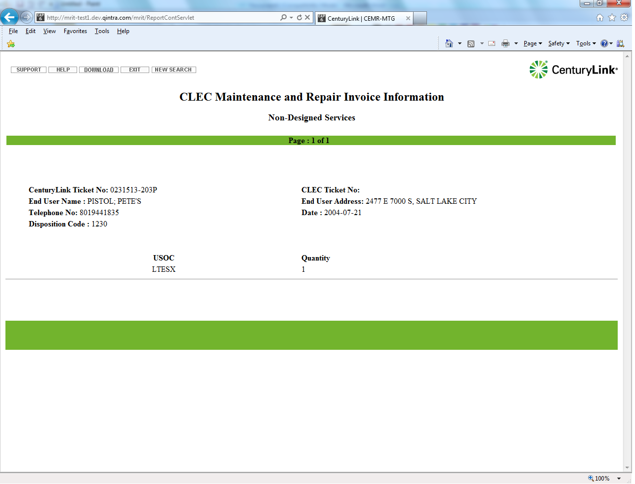
DO NOT use the browser Back button to return to previous screens. Instead, use the buttons in the top left navigation bar, or from the report screen, use the Previous Page and Next Page buttons.

The following table describes each field on this invoice. Fields are listed alphabetically.

Field Name | Description
CLEC Ticket No | Issue number assigned by the CLEC. If the ticket was not created in CEMR-MTG, or if it was not assigned a ticket number in CEMR-MTG, this number is not available.
Date | Date the ticket was closed.
Disposition Code | Disposition code entered by the repair technician.
End User Address | Address of the end user (customer) for whom the work was performed. In some cases, this field may be empty, or it may reflect the CLEC address.
End User Name | Name of the end user (customer) for whom the work was performed. In some cases, this field may be empty, or it may reflect the CLEC name.
Quantity | Dispatch charges.
CenturyLink Ticket No | Issue number assigned in the CenturyLink ticketing system.
Telephone No | End user working telephone number.
USOC | Universal Service Order Code. Standard code assigned to telecommunications service offerings, e.g., LTESX and MCE.

Exporting and Printing Invoice Reports
In this section:
- Export a Report
- Print a Report

Export a Report
To export a report, use these steps:
Log in to the application using your CEMR-MTG user name and password to display the Search window.
Click the appropriate radio button to choose Designed or Non-designed invoices, enter any other criteria you want to use for the search, and click the button to begin the search. The system displays all invoices of the type you chose.
In the top left navigation bar, click the button. The system downloads all of the repair invoices it found to a Microsoft® Excel spreadsheet. When the system File Download window opens, you can elect to save the file to location of your choice, or open the file from its current location.

After you open the file, use the Excel application tools to format, sort, filter, save, or print the data as you would in any Excel spreadsheet.

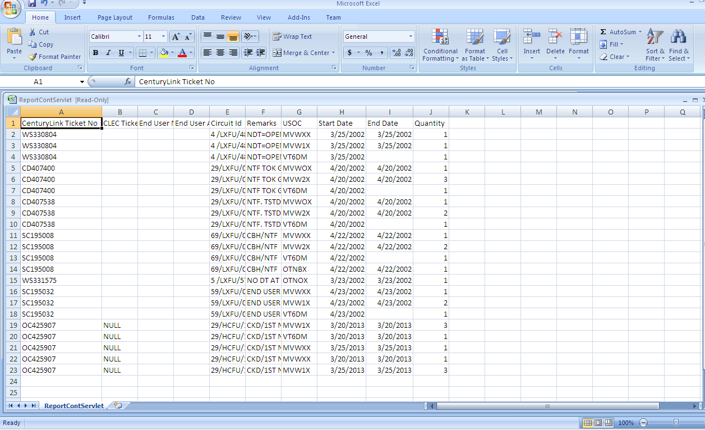

Print a Report
To print a report, you must first export it to a Microsoft® Excel spreadsheet. (See Export a Report.)
Once the report is in Excel, you can use any of the Excel application tools to format, sort, filter, save, or print the data.

Sorting and Filtering the Data
You can sort and filter the report data by downloading the report to a Microsoft® Excel spreadsheet first. At the top of the report page, click the button. The system downloads the data to a Microsoft® Excel spreadsheet. Use the Excel application tools to sort and filter the data as you would in any Excel spreadsheet. (See Export a Report.)

Getting Technical Support
To get application technical support, click the button in the top left navigation bar. A window opens with help desk technical support contact information.
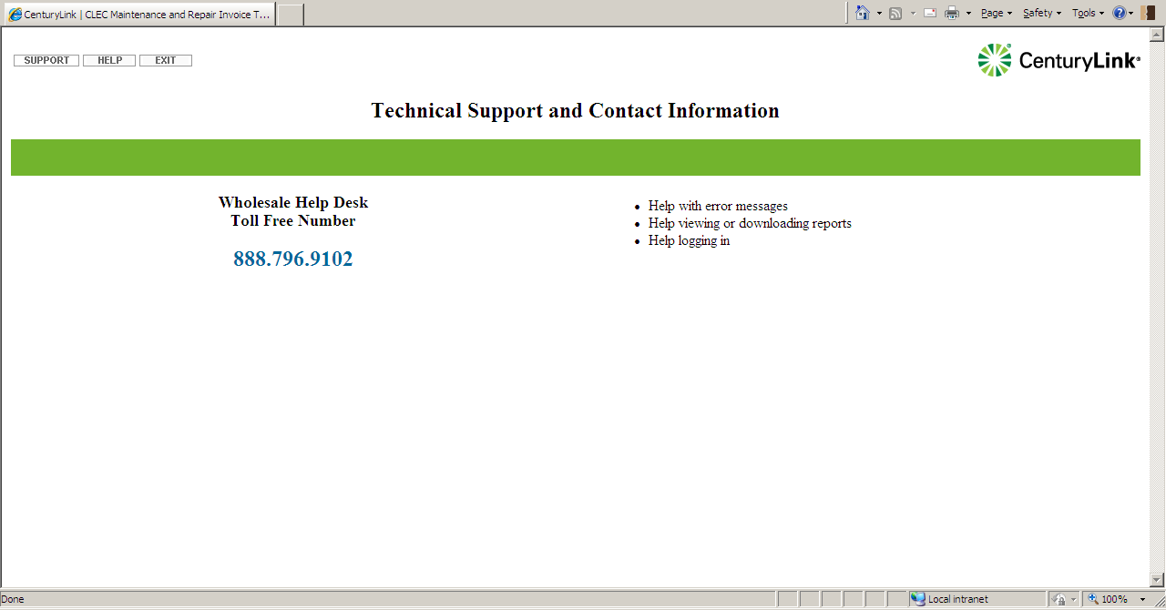

Appendix A: Circuit ID Format Tutorial
In this section:
- Recognize Serial Number Circuit ID Formats
- Recognize Telephone Number Circuit ID Formats
- Recognize Carrier Facility Circuit ID Formats
- Recognize Message Trunk Circuit ID Formats
Important: The characters in the circuit ID must be exact. No fuzzy logic exists to reconcile circuit id fragments. All digits are treated as characters and have value associated with them (e.g. leading zeroes are treated as a valid part of the circuit ID).

Serial Number Circuit ID Formats
A serial number circuit ID format consists of the following components. Blank spaces must be entered exactly as they appear in the original record.
- Prefix: A 1- to-2 alphanumeric character portion of a serial number circuit ID format. This field is required. If the prefix is a single character, add a leading space or trailing space as it appears in the original record.
- Service Code and Modifier: A two to four alphabetic character portion of a serial number circuit ID format. The service code and modifier, which are usually four alphabetic characters, are preceded by a slash (/) and always follow the prefix when they are part of a serial number circuit ID format. This field is required.
- Serial Number: A one to six digit portion of a serial number circuit ID format. The serial number is always preceded by a slash (/) and follows the service code and modifier (if one exists in the circuit ID). If the service code and modifier do not appear in the circuit ID, the serial number directly follows the prefix. This field is required and must include six characters or spaces.
Important: You must enter a blank space between the serial number and the suffix.
- Suffix: A three alphanumeric character portion of a serial number circuit ID format. The suffix, which is rarely present within a serial number circuit ID format, is an extension of the serial number and is preceded by a blank space. This field is required and must include three characters. Enter three blank spaces if the suffix is blank.
- CO Code: A two to four alphanumeric character portion of a serial number circuit ID format. The CO code, which appears in a majority of serial number circuit ID formats, is preceded by a slash (/) and follows the serial number. The CO code is MS, PN, or NW. This field is required.
- Segment: A one to three alpha character portion of a serial number circuit ID format. The segment, which is rarely present within a serial number circuit ID format, is preceded by a slash (/) and follows the CO code (company code). If the CO code does not appear in the circuit ID, the segment follows the Serial number (and possibly the Suffix). This field is optional except for multi-point circuits. The CenturyLink backend OSS requires the alpha character that designates the circuit end location (CKL) for a multipoint circuit. The Control or CKL1 location is always segment A. CKL2 is always segment B, CKL3 is always segment C, etc. In the event the number of segments exceeds 26 (Z), then the segments are designated AA (CKL 27), AB (CKL 28), etc.
A sample serial number circuit ID format is shown in the following figure. Note that the prefix, service code and modifier, serial number, and CO code are the components that comprise a majority of the serial number circuit ID formats.
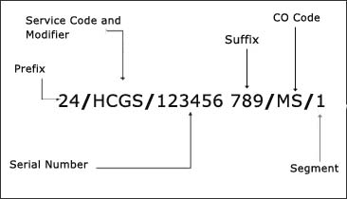
Figure A-1: Serial Number Circuit ID Format
Important: A billing telephone number (BTN) cannot be used to open a trouble report (e.g., 303-W55-1111) The ticket must be opened using the serial number circuit ID.

Telephone Number Circuit ID Formats
A telephone number circuit ID format consists of the following components:
- Prefix: A 1 or 2 alphanumeric character portion of a telephone number circuit ID format. Circuit IDs may or may not contain a prefix. If no prefix exists, leave field blank and continue with next field.
- Service Code and Modifier: A two to four alphanumeric character portion of a telephone number circuit ID format. The service code and modifier, which are usually four alphabetic characters, are preceded by a slash (/) and always follow the prefix when they are part of a telephone number circuit ID format. This field is required.
- NPA: A three numeric character portion of a telephone number circuit ID format. The NPA is preceded by a slash (/) and follows the service code and modifier (if one exists in the circuit ID). If the service code and modifier does not appear in the circuit ID, the NPA follows the prefix. This field is required.
- NXX: A three numeric character portion of a telephone number circuit ID format. The NXX is preceded by a slash (/) and follows the NPA. This field is required.
- Line: A four numeric character portion of a telephone number circuit ID format. The line is preceded by a slash (/) and follows the NXX. This field is required.
- Extension: A one to five alphanumeric character portion of a telephone number circuit ID format. The extension is preceded by a slash (/) and follows the line. This field is optional. For CenturyLink Central Region circuits (CO, NM, UT, WY, MT AZ, ID), alpha characters are not accepted. If your circuit records show an extension of D1, use the value 0001. If your records show an extension of D2, use 0002; for D3, use 0003; etc.
- Segment: A one to three alphanumeric character portion of a telephone number circuit ID format. The segment, which is rarely present within a telephone number circuit ID format, is preceded by a slash (/) and follows the extension (if one exists in the Circuit ID). If the extension does not appear in the circuit ID, the segment follows the line. This field is optional.
A sample telephone number circuit ID format is shown in the following figure. Note that the prefix, service code and modifier, NPA, NXX, and line are the components that comprise a majority of the telephone number circuit ID formats.

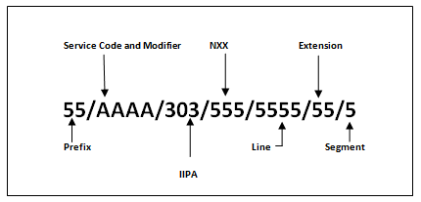
Figure A-2: Telephone Number Circuit ID Format

Carrier Facility Circuit ID Formats
A carrier facility circuit ID format consists of the following components:
- Channel Group Number: A one to five alphanumeric character portion of a carrier facility circuit ID format. The channel group number is always the first portion of the carrier facility circuit ID format. This field is required.
- Facility Type: A one to six alphanumeric character portion of a carrier facility circuit ID format. The facility type is preceded by a slash (/) and follows the channel group number. This field is required.
Some possible facility types include:
T1 | T1UZF | T1F
T1Z | T1U | T1ZF
T3 | T1UF | T1ZT

- A Location CLLI Code: An eight or 11 alphanumeric character portion of a carrier facility circuit ID format. The A location CLLI (Common Language Location Identification) Code, which identifies one of the two locations between which a circuit resides, is preceded by a slash (/) and follows the facility type. This field is required.
- Z Location CLLI Code: An eight or 11 alphanumeric character portion of a carrier facility circuit ID format. The Z location CLLI code, which identifies one of the two locations between which a circuit resides, is preceded by a slash (/) and follows the A location CLLI code. This field is required.
A sample carrier facility circuit ID format is shown in the following figure. Note that all four carrier facility circuit ID format components (channel group number, facility type, A and Z CLLI codes) are always present in a carrier facility circuit ID format.
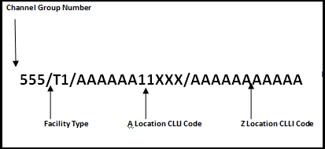
Figure A-3: Carrier Facility Circuit ID Format

Message Trunk Circuit ID Formats
A message trunk circuit ID format consists of the following components:
- Trunk Number: A one to four alphanumeric character portion of a message trunk circuit ID format. The trunk number is always the first portion of the message trunk circuit ID format. This field is required.
- Traffic Class: A one to two alphanumeric character portion of a message trunk circuit ID format. A dash (-) is also acceptable in this field. The traffic class is preceded by a slash (/) and follows the trunk number. This field is required.
- Office Class: A one to two alphanumeric character portion of a message trunk circuit ID format. A dash (-) is also acceptable in this field. The office class directly follows the traffic class. (traffic class and office class are separated by neither a slash nor space.) This field is required.
- Traffic Use Code: A two alphanumeric character portion of a message trunk circuit ID format. A dash (-) is also acceptable in this field. The traffic use code directly follows the office class. (office class and traffic use code are separated by neither a slash nor space.) This field is required.
- Traffic Modifier: A one to seven alphanumeric character portion of a message trunk circuit ID format. The traffic modifier, if present within the circuit ID, follows the traffic use code. (traffic use code and traffic modifier are separated by neither a slash nor space.) This field is optional.
- A Location CLLI Code: An eight or 11 alphanumeric character portion of a message trunk circuit ID format. The A location CLLI code, which identifies one of the two locations between which a circuit resides, is preceded by a slash (/) and follows the traffic modifier (if one exists in the circuit ID). If the traffic modifier does not appear in the circuit ID, the A location CLLI code follows the traffic use code. This field is required.
- Pulse and Direction: A two alphanumeric character portion of a message trunk circuit ID format. The pulse and direction code is preceded by a slash (/) and follows the A location CLLI code. This field is required.
- Z Location CLLI Code: An eight or 11 alphanumeric character portion of a message trunk circuit ID format. The Z location CLLI code, which identifies one of the two locations between which a circuit resides, is preceded by a slash (/) and follows the pulse and direction code (if one exists in the circuit ID). If the pulse and direction code does not appear in the circuit ID, the Z location CLLI code follows the A location CLLI code. This field is required.
A sample message trunk circuit ID format is shown in Figure A-4.
Important: All message trunk circuit ID format components (trunk number, traffic class, office class, traffic use code, traffic modifier, A and Z CLLI codes, pulse and direction) are present in a majority of the message trunk circuit ID formats.
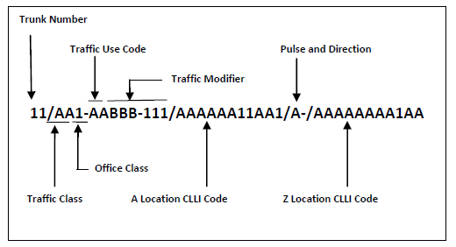
Figure A-4: Message Trunk Circuit ID Format

