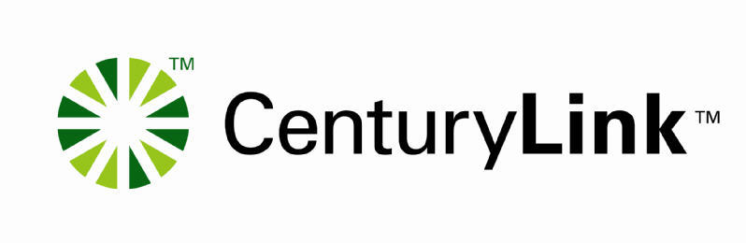
Tuesday, February 8, 2005
Customer Company Name
Dear Customer
This letter summarizes activity on the following dispute:
Main Billing Account Number: 000 000-0000 000
Bill Date: 1/20/2005
Customer Claim Number:
CenturyLink ID #: 20202
Amount in Dispute: $38.92
Below are the details related to the resolution of this dispute.
ID | Type | Status | Amt | Items | Resolved  QWEST | Resolved  Cust | Credit Dates | Resolved | ST/Cost Docket,  Tariff, SGAT/Contract  Service Order
1 | Rates-NRC-Service Issue | Resolved | $38.92 | 1 | $0.00 | $38.92 | 1/20/2005 - 1/20/2005 | 2/8/05
Item Totals |  |  | $38.92 | 1 | $0.00 | $38.92
$38.92 was resolved in Customer Favor.
Credits should appear within two billing cycles.
Resolved items will remain closed unless further disputes related to this item are submitted to CenturyLink in writing.
Thank you,
Wholesale Billing Service Delivery Coordinator
CenturyLink Wholesale Billing Department
303 000-00000

